# **Table of Contents**

Table of Contents 1

IAM 2

**AWS CLI Class Room Discussion** 2

**Screenshots for Windows/Mac/Linux Installation** 3

**Screenshot for configuring Access Keys for AWS CLI** 6

**Screenshot for Configuring AWS CLI** 7

**Screenshot for Checking AWS folder on Windows** 8

**Screenshot for accessing another AWS account** 9

**Screenshot for launching a New EC2 Instance using CLI** 10

**Screenshots for creating IAM user with a console password and assign a role** 12

**Screenshots for** **providing CLI (programmatic) access to an existing IAM user** 17

**Screenshots for** **creating a user group and assign policies in AWS** 21

**Difference between default, customs and inline policies** 23

**Screenshots for** **creating a custom polices** 23

**Screenshots for** **creating a inline polices** 30

**Screenshots for** **creating a IAM Role** 35

**Assign and test an IAM role on an Public and private EC2 instance** 37

**Assign and test Role on Public EC2 Instance** 37

**Assign and test Role on Private EC2 Instance** 39

# IAM

### **AWS CLI Class Room Discussion**

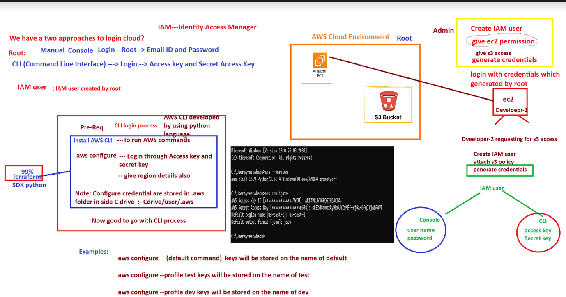

### **Screenshots for Windows/Mac/Linux Installation**

Visit the official AWS CLI download page: [AWS CLI Installation](https://docs.aws.amazon.com/cli/latest/userguide/getting-started-install.html)

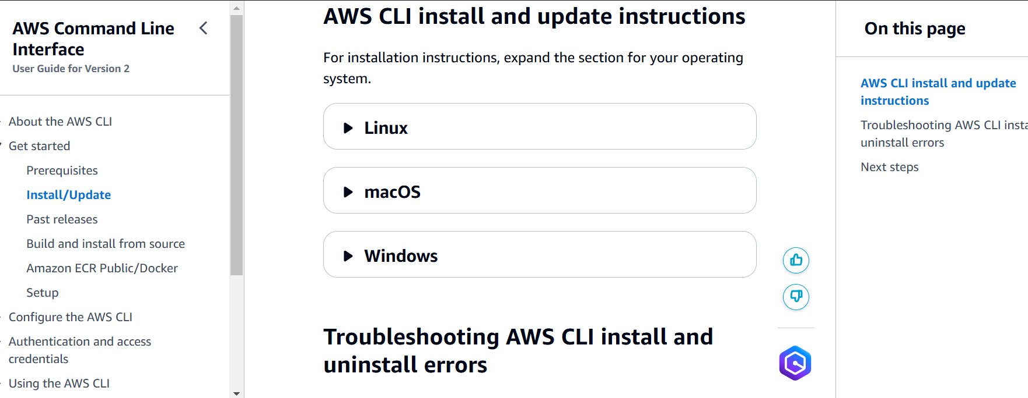

Download and install the appropriate version for your operating system

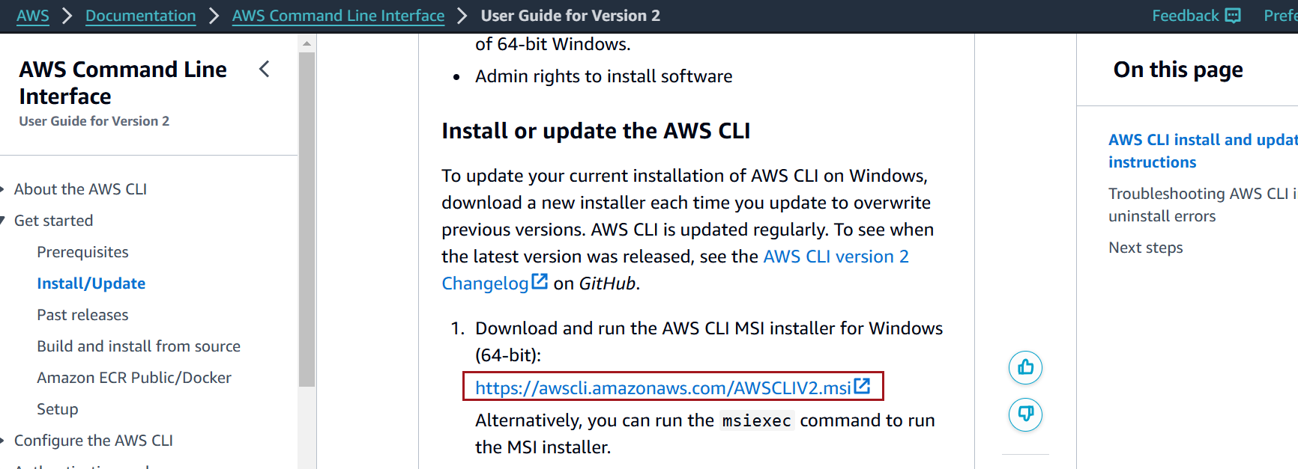

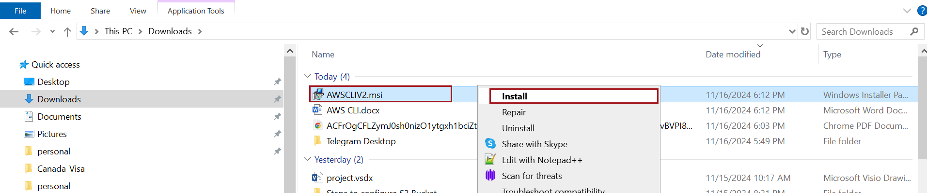

Proceed with the defaults by clicking "Next."

Verify Installation

Open a terminal or command prompt

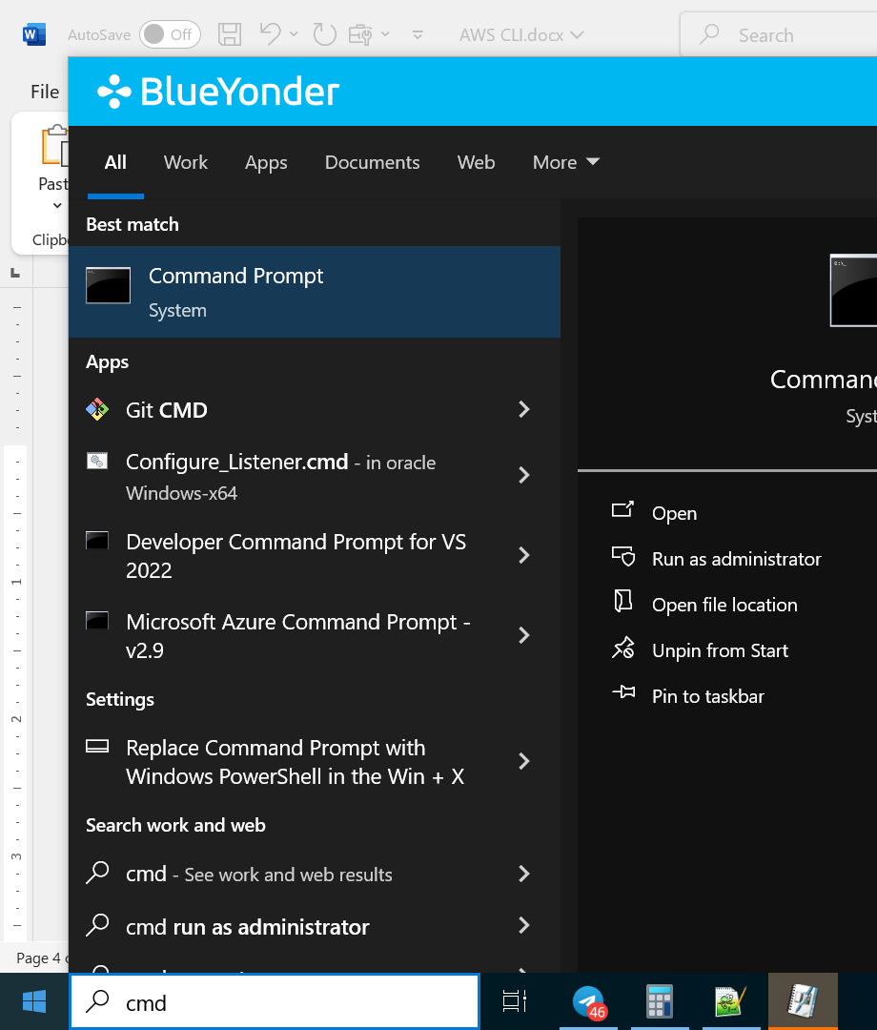

Run below command

aws --version

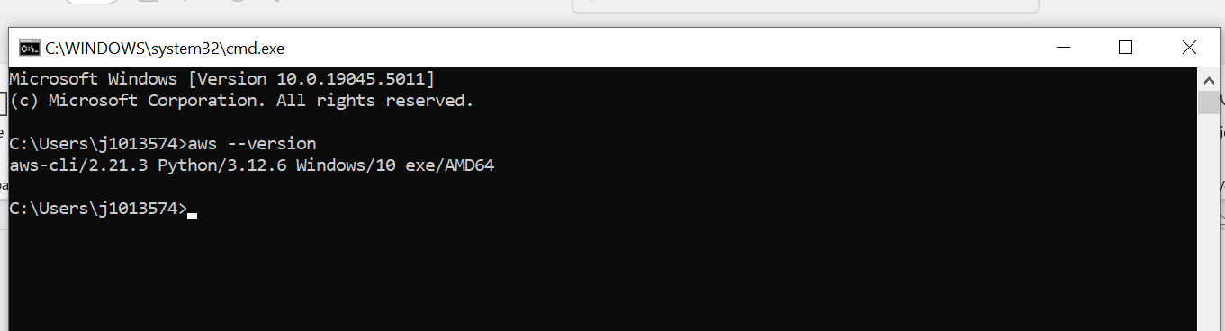

### **Screenshot for configuring Access Keys for AWS CLI**

In the top-right corner of the AWS Management Console, click your **account name** or **account ID** (depending on your setup).

Select **Security Credentials** from the dropdown menu

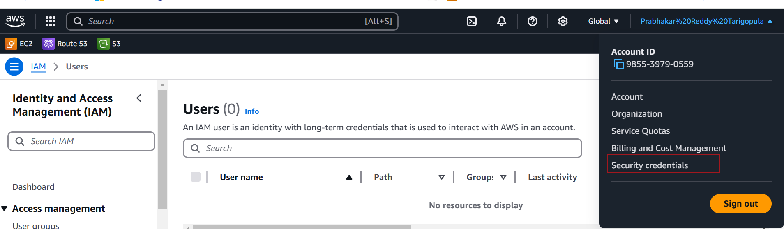

Scroll down to the **Access keys** section and click **Create access key**

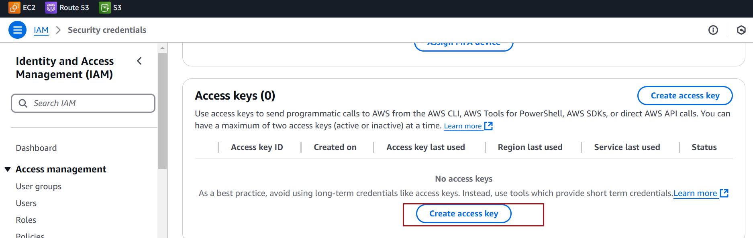

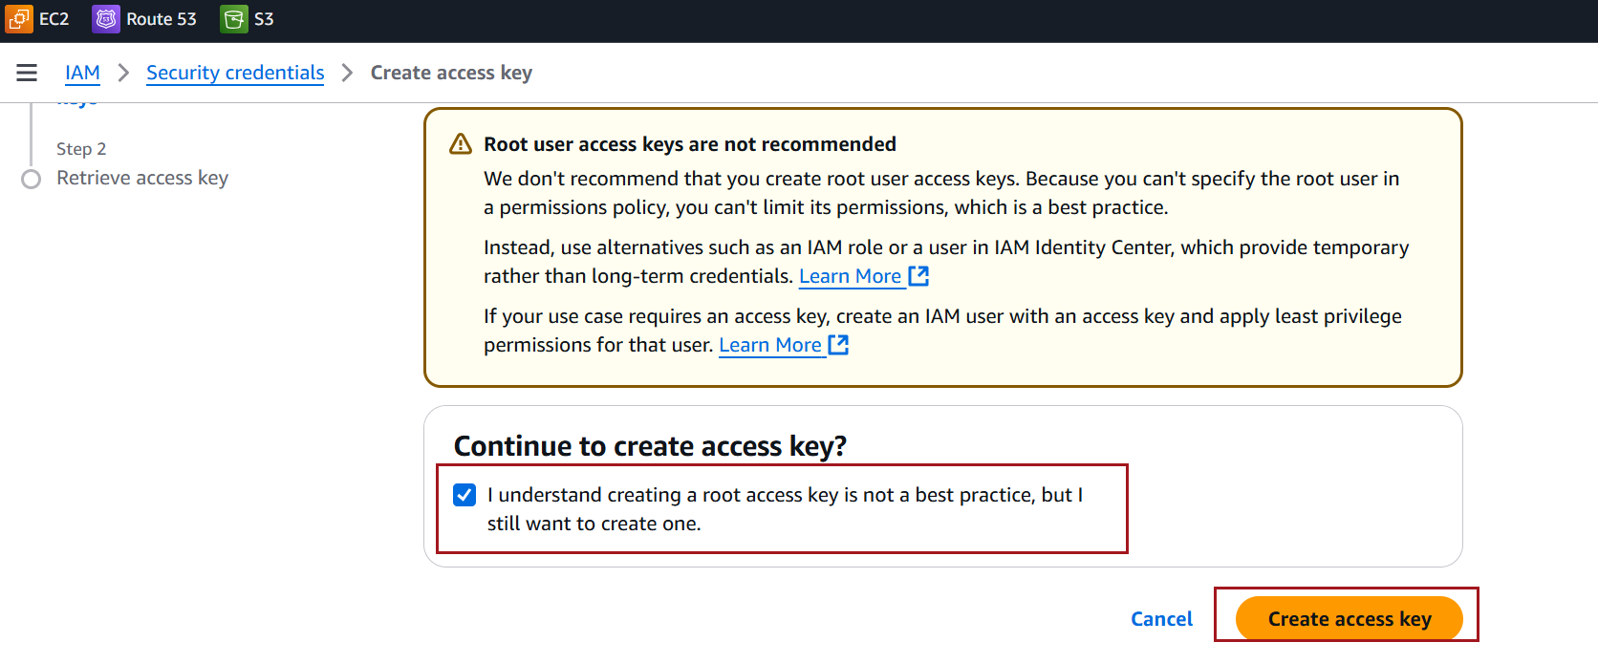

Save the .csv file in a secure location and click on Done

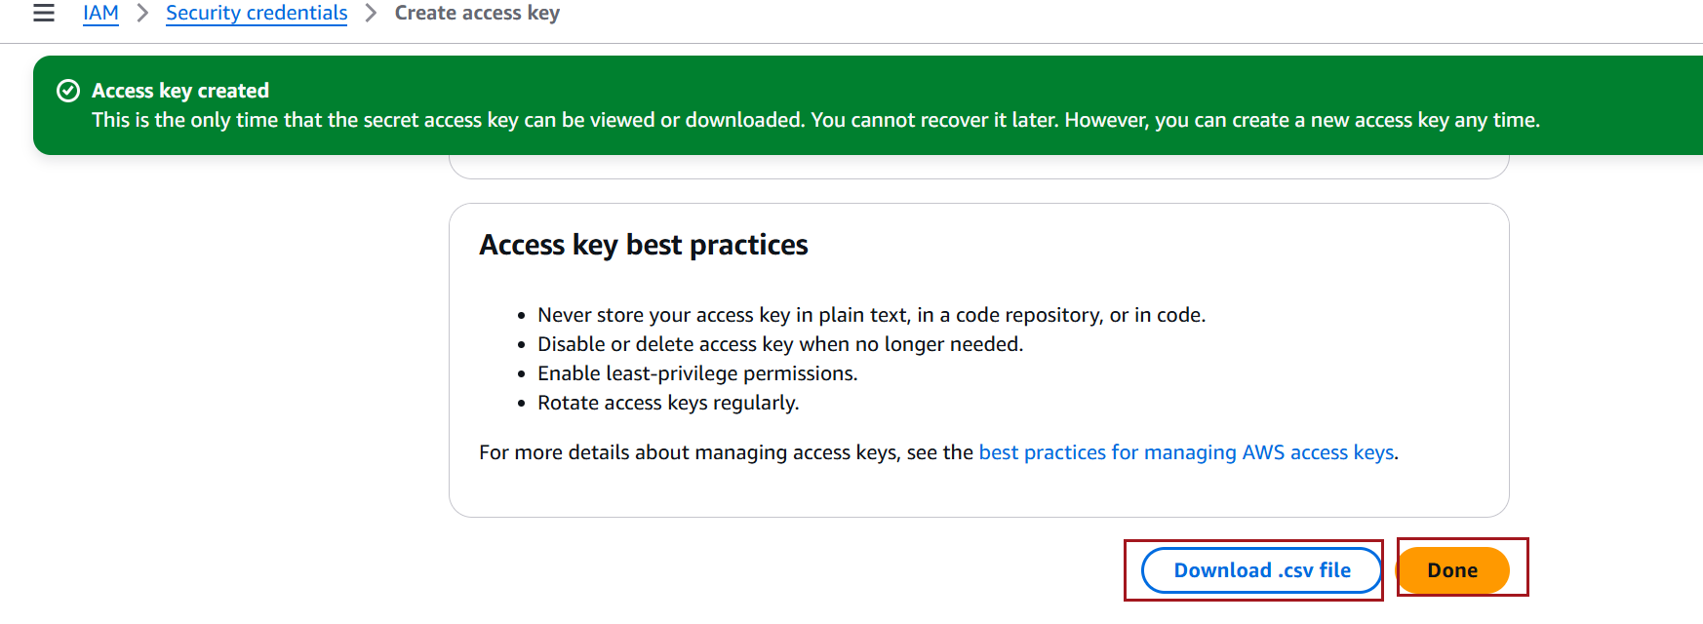

Observe that access keys created

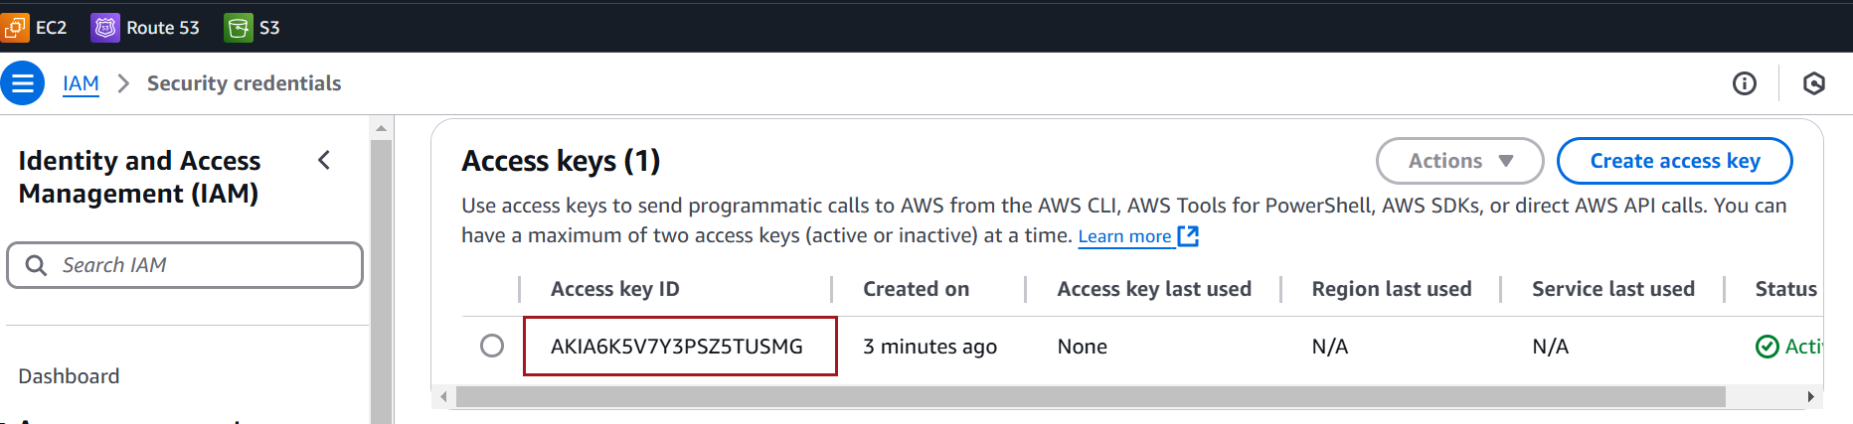

### **Screenshot for Configuring AWS CLI**

Open a terminal or command prompt.

Run aws configure

Enter the following details:

* **AWS Access Key ID**: Enter your Access Key ID.
* **AWS Secret Access Key**: Enter your Secret Access Key.
* **Default region name**: Enter the AWS region (e.g., us-east-1 or ap-south-1).
* **Default output format**: Choose json, table, or text (default is json).

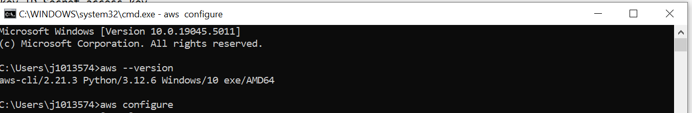

Region

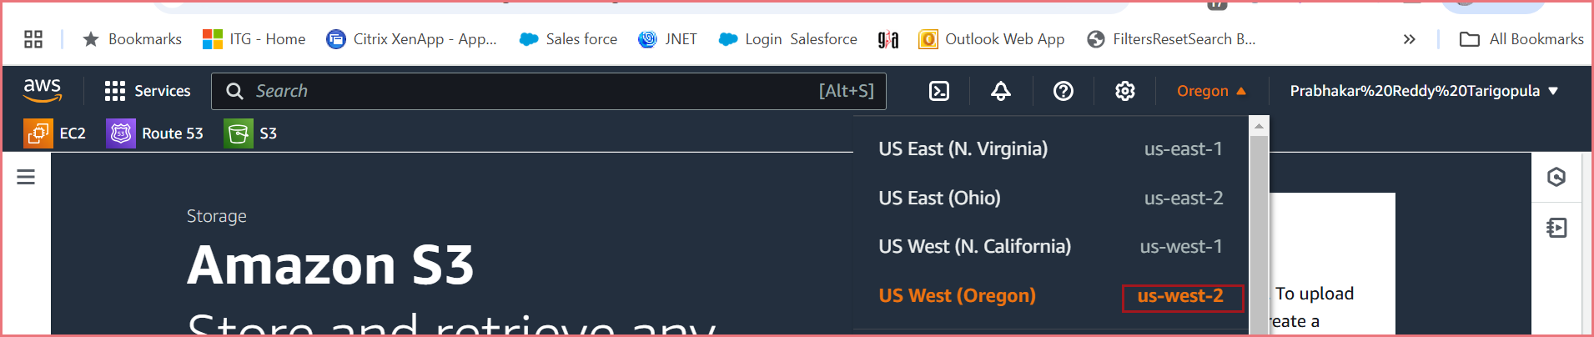

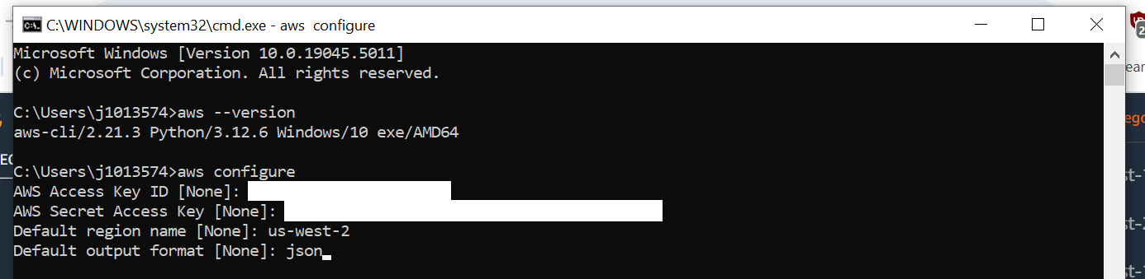

Test Configuration

Try listing your **S3 buckets** to test if AWS CLI can interact with your AWS account

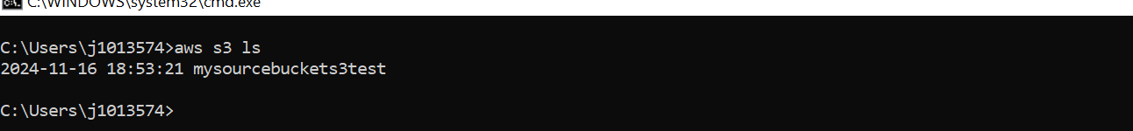

### **Screenshot for Checking AWS folder on Windows**

Open **File Explorer**.

C:\Users\<YourName>\.aws

Inside the .aws folder, you should see two key files:

* **config**: Contains settings like the default region and output format.
* **credentials**: Contains the Access Key ID and Secret Access Key for your configured profiles.

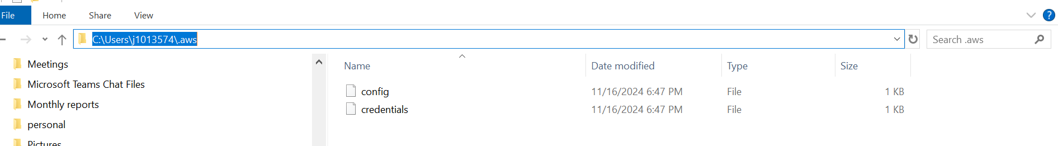

### **Screenshot for accessing another AWS account**

**Run the aws configure command** with a custom profile name for the other account. You can give any name to the profile e.g., another-account

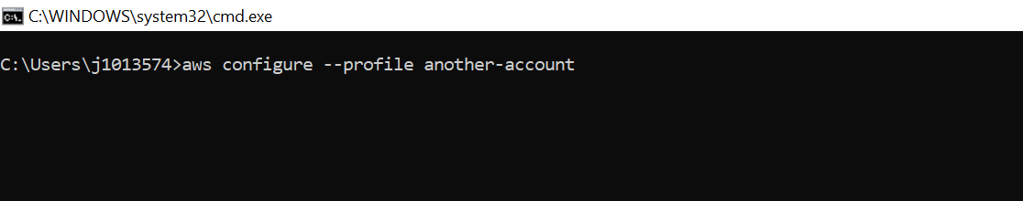

**Enter the credentials for the other account**:

* **AWS Access Key ID**: Enter the access key for the other account.
* **AWS Secret Access Key**: Enter the secret key for the other account.
* **Default region name**: You can press **Enter** to accept the default region, or specify a region (e.g., us-west-2).
* **Default output format**: Press **Enter** to accept the default json, or specify your preference (e.g., text or table).



**Use the Other Account via the Named Profile**

Once the profile for the other account is configured, you can run AWS CLI commands using the --profile option to specify the account you want to use.

aws s3 ls --profile another-account

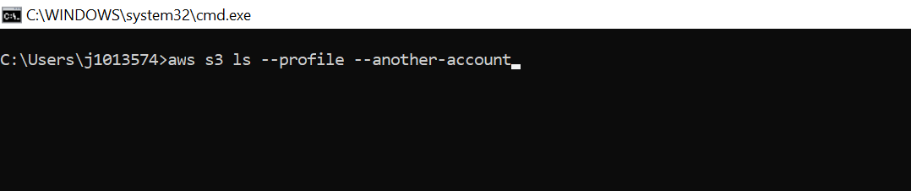

### **Screenshot for launching a New EC2 Instance using CLI**

Creating an **EC2 instance** using the AWS CLI involves multiple steps

**Prerequisite list required for EC2 instance creation through the AWS CLI**:

* **AMI ID**: Amazon Machine Image ID (e.g., ami-12345).
* **Instance Type**: Instance size/type (e.g., t2.micro).
* **Key Pair**: For SSH access to the instance.
* **Security Group**: For firewall rules.

**Run the following command to create an EC2 instance:**

aws ec2 run-instances --image-id ami-22111148 --count 1 --instance-type t1.micro --key-name stage-key --security-groups my-aws-security-group

Note - If you are in a default VPC and want AWS to automatically assign the default security group, omit the --security-group-ids parameter entirely:

aws ec2 run-instances --image-id ami-01f9f821c37661b97 --count 1 --instance-type t2.micro --key-name newkey

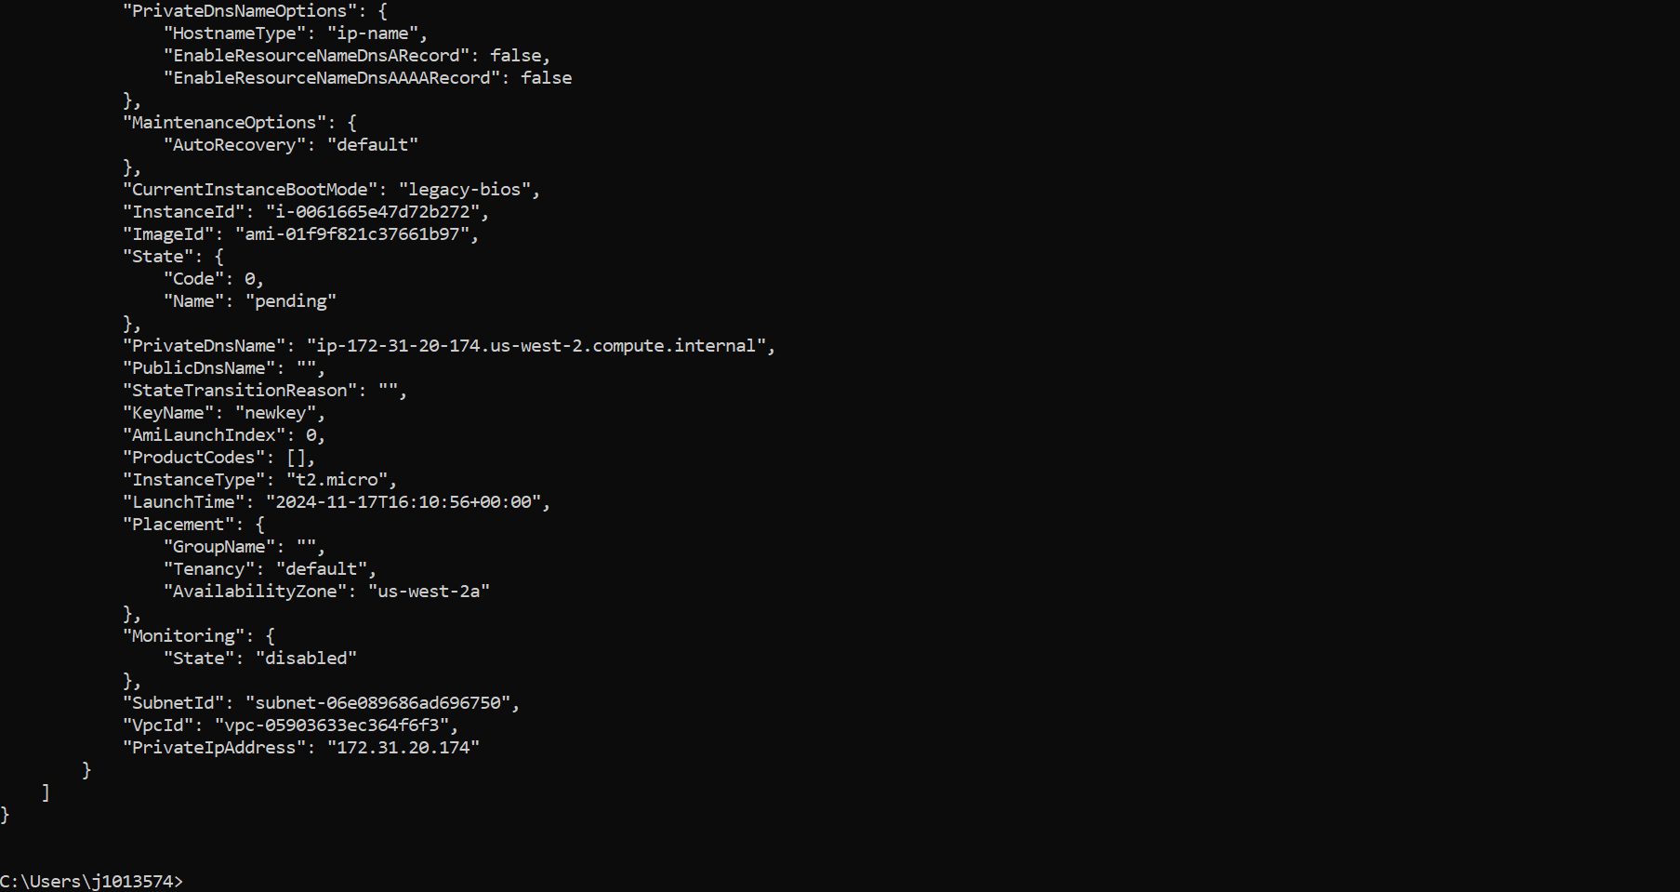

To see the list of all EC2 instances in your AWS account, use the following AWS CLI command

aws ec2 describe-instances --query "Reservations[*].Instances[*].[InstanceId,State.Name]"

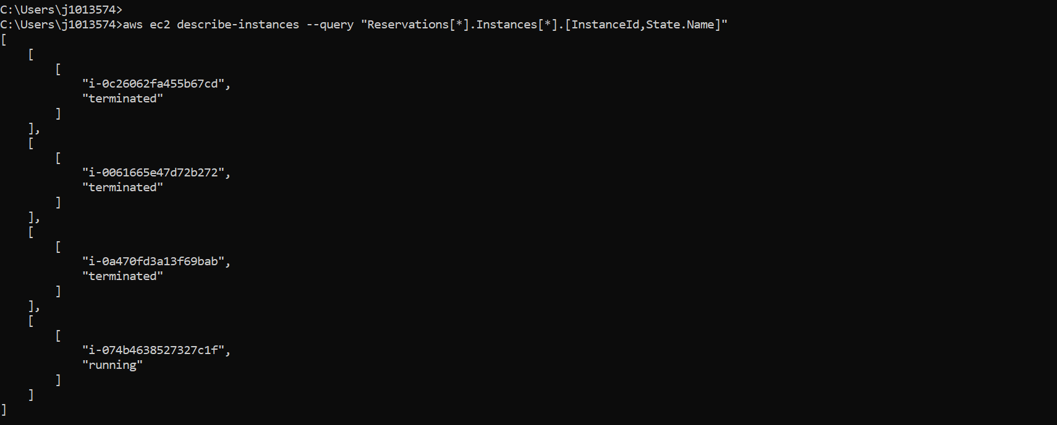

### **Screenshots for creating IAM user with a console password and assign a role**

Create the User

Navigate to the **IAM Dashboard,**

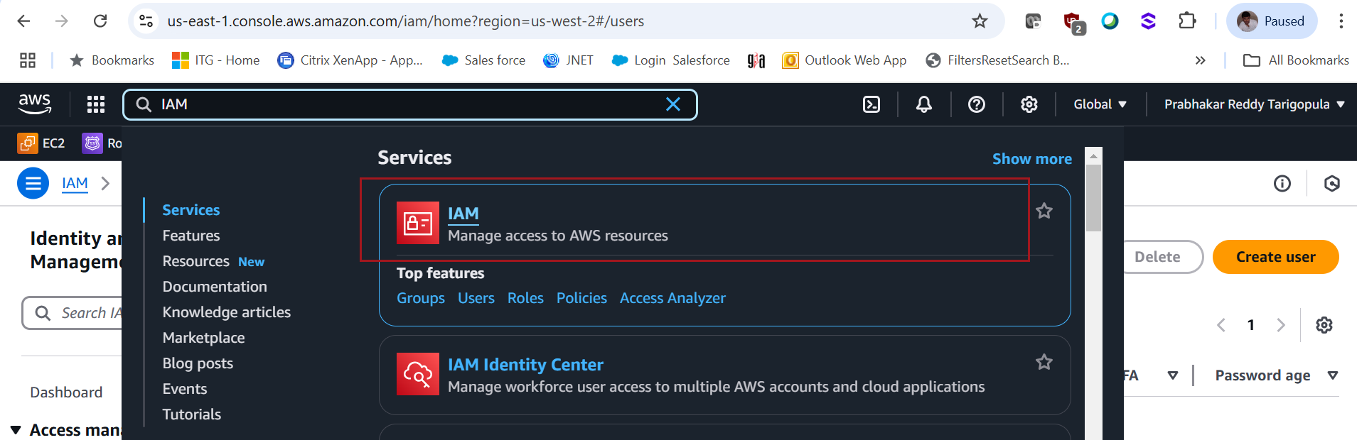

In the left-hand menu, click on **Users**, then click the Create **user** button

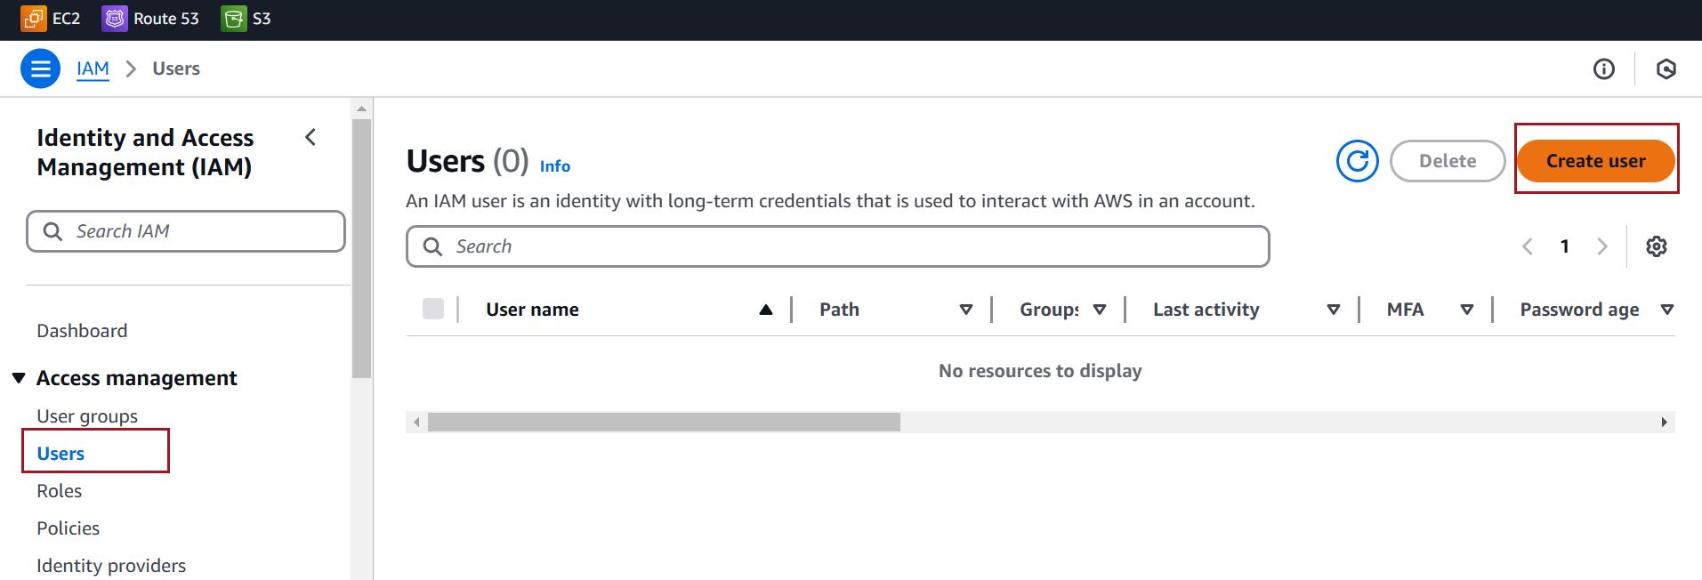

Enter the **User name**.

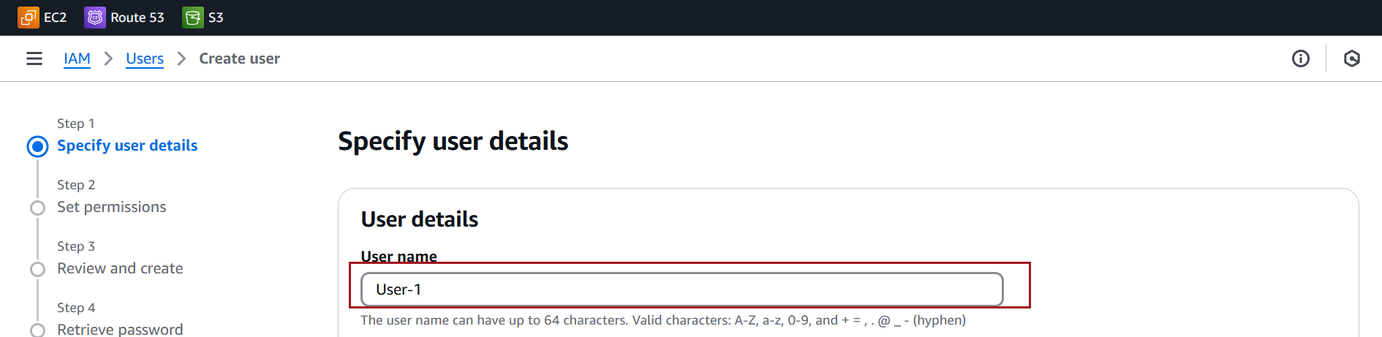

Check the box for Provide user access to the AWS Management Console (optional).

Enable the "**I want to create an IAM user" option**

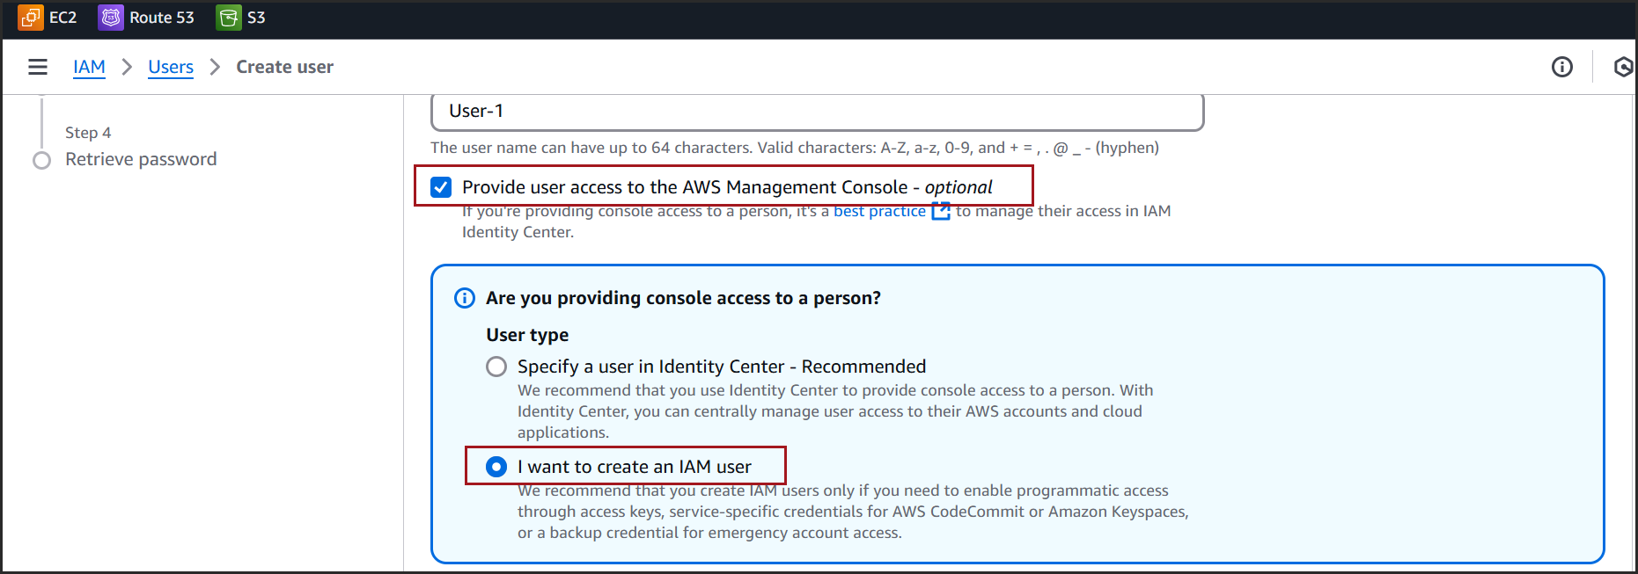

Set the **Console password**

**Custom password**: Enter a password manually

Optionally, check **Require password reset** at the next login

Click on Next

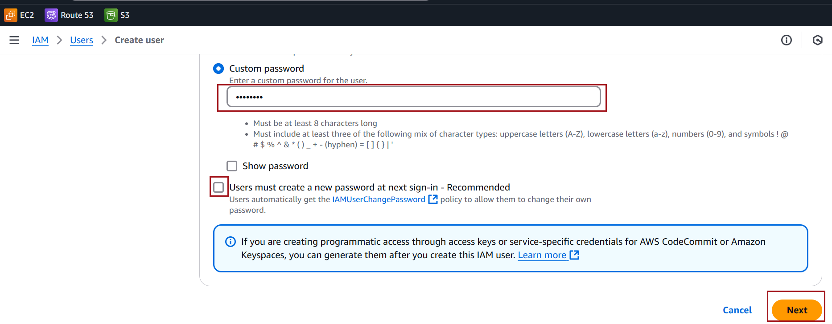

On the **Set permissions** page, choose **Attach policies directly**

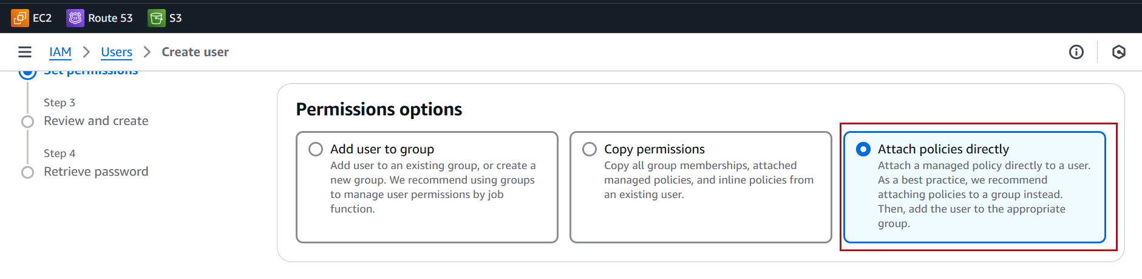

In the list of policies, search for **"AmazonS3FullAccess**

Check the box next to the **AmazonS3FullAccess** managed policy

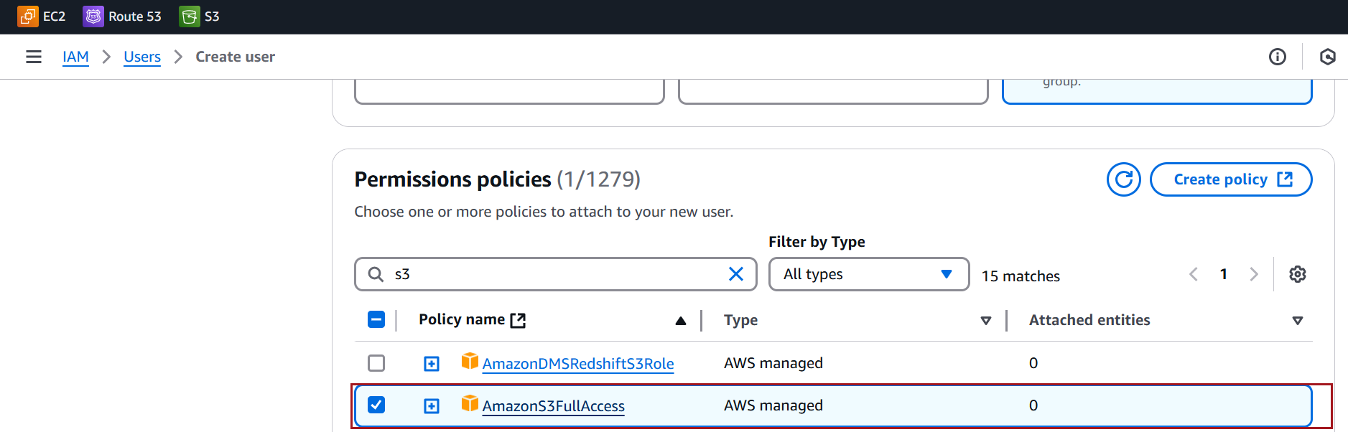

Click on Next

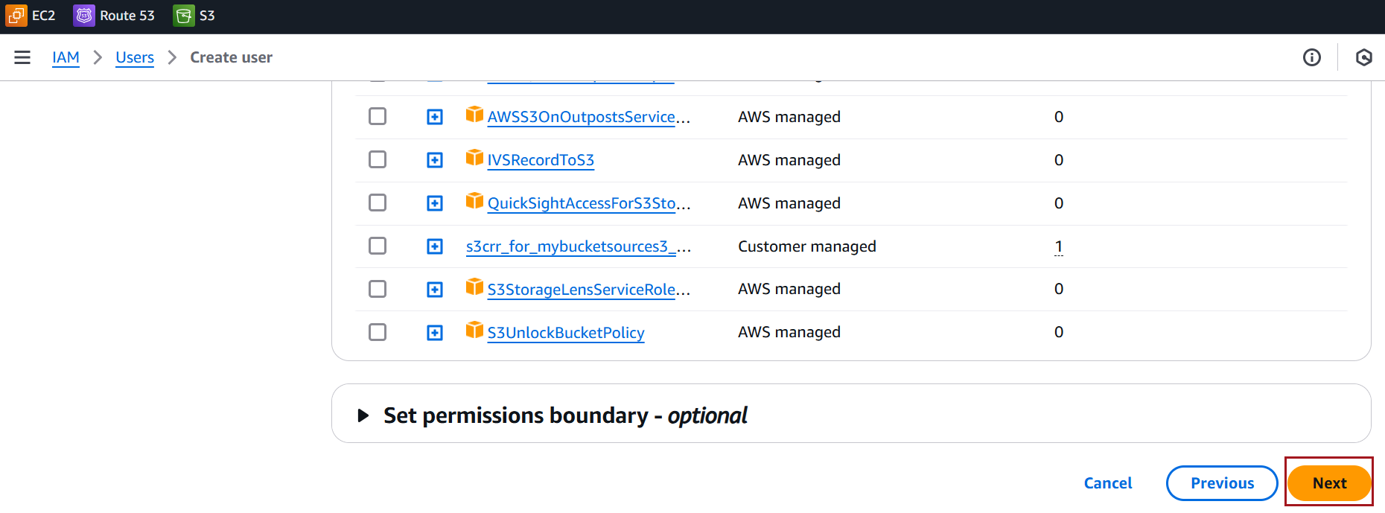

Click **Create user**

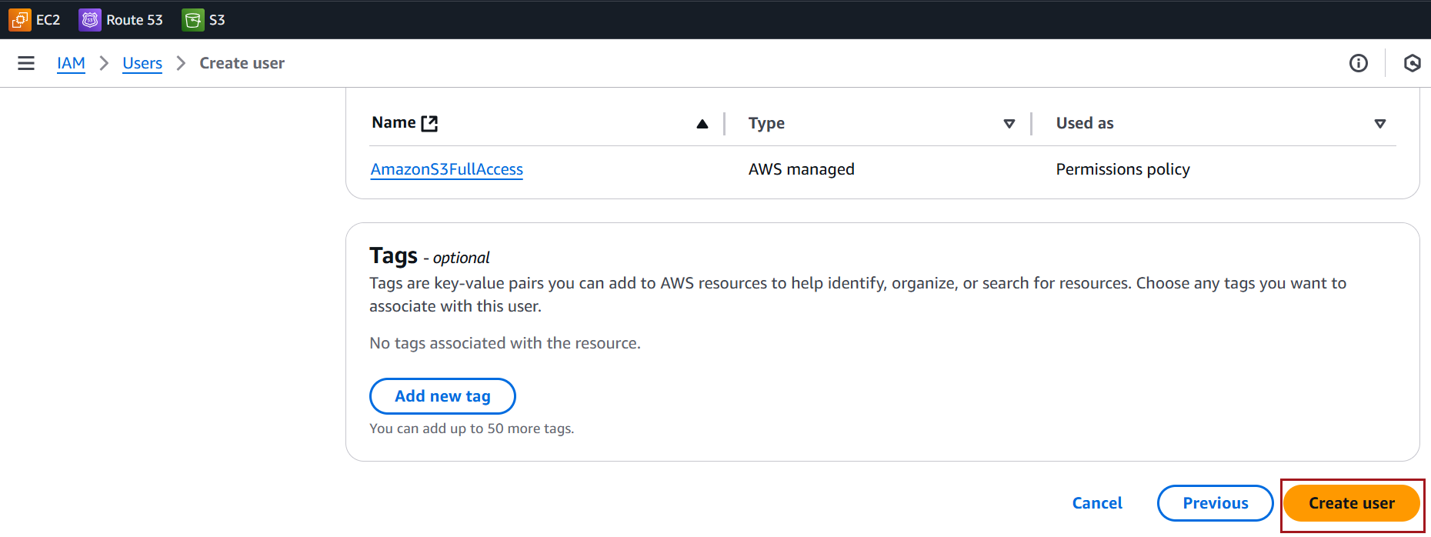

Copy the **Console sign-in URL** from summery page after user created

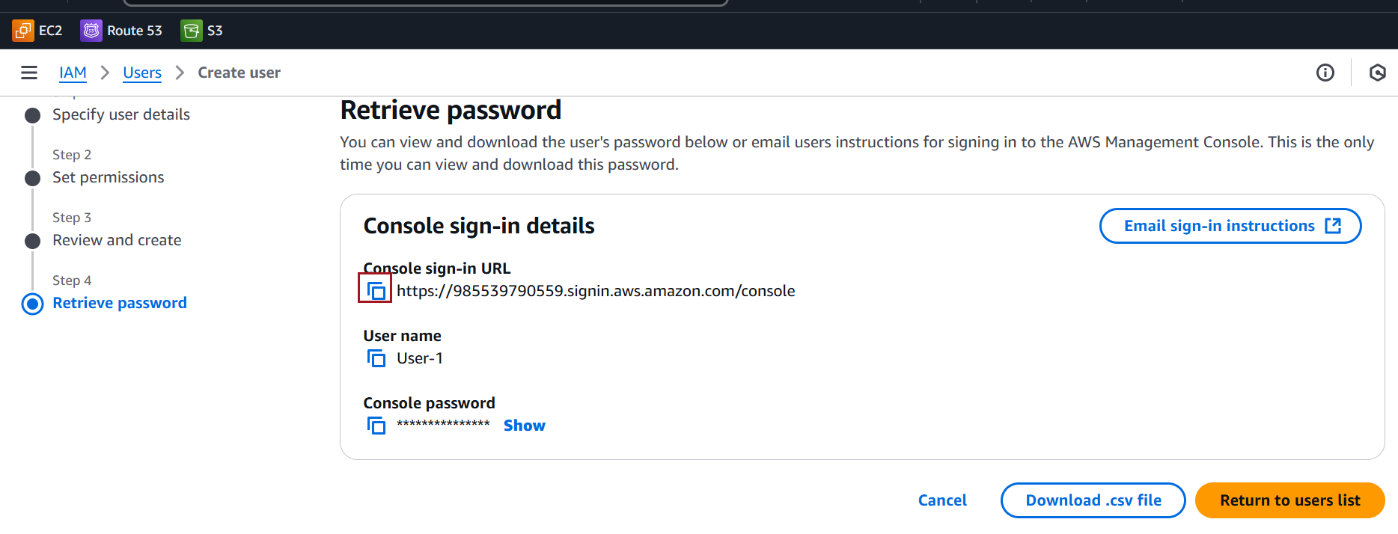

If you didn't copy the URL at the time of user creation, you can find it later:

On the **IAM Dashboard**, look for the **IAM users** section.

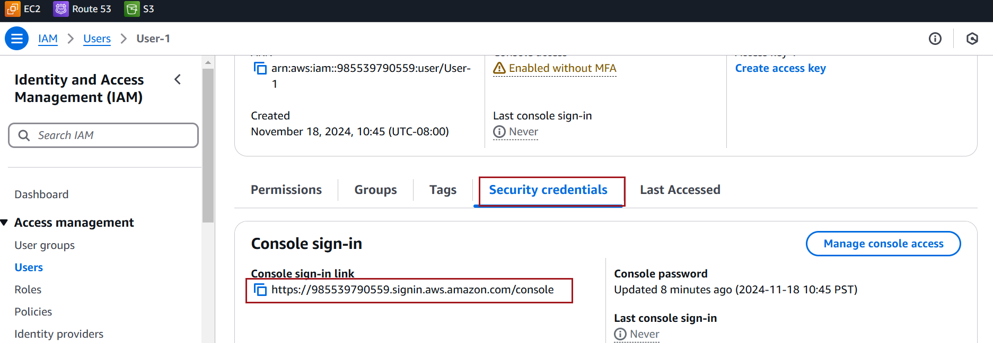

Share the Console Sign-In URL

After copying the sign-in URL, Inform the user to use the URL for logging in and, if required, reset their password during the first login.

Observe that user is able to see S3 buckets created by root users

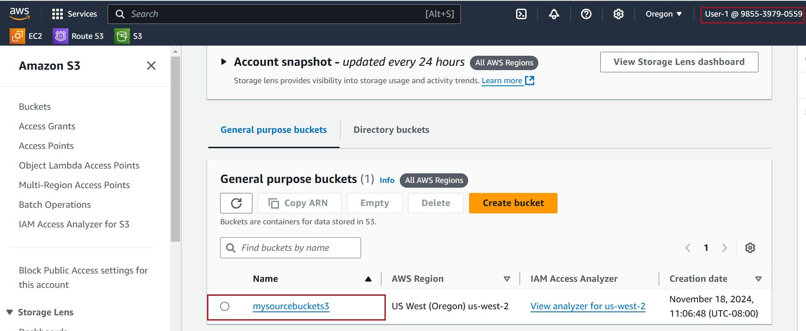

### **Screenshots for** **providing CLI (programmatic) access to an existing IAM user**

In the left-hand menu, click **Users**.

Select the **existing user** you want to provide CLI access to.

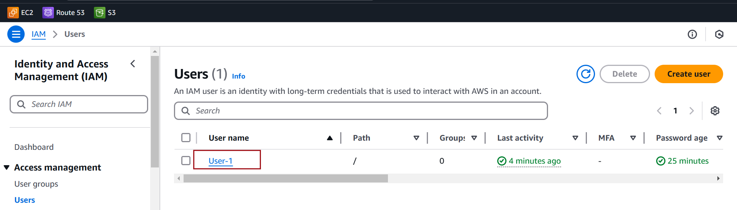

On the user's **Summary page**, click on the **Security credentials** tab.

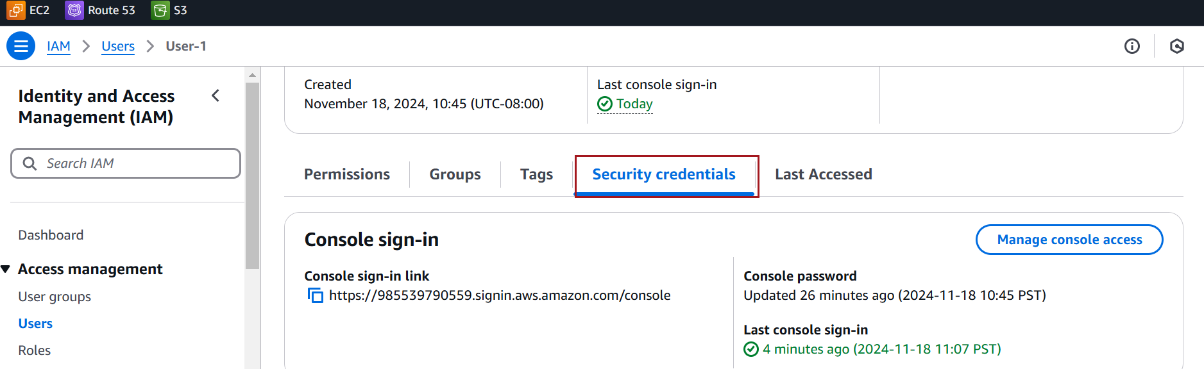

Scroll down to the **Access keys** section. Click **Create access key**

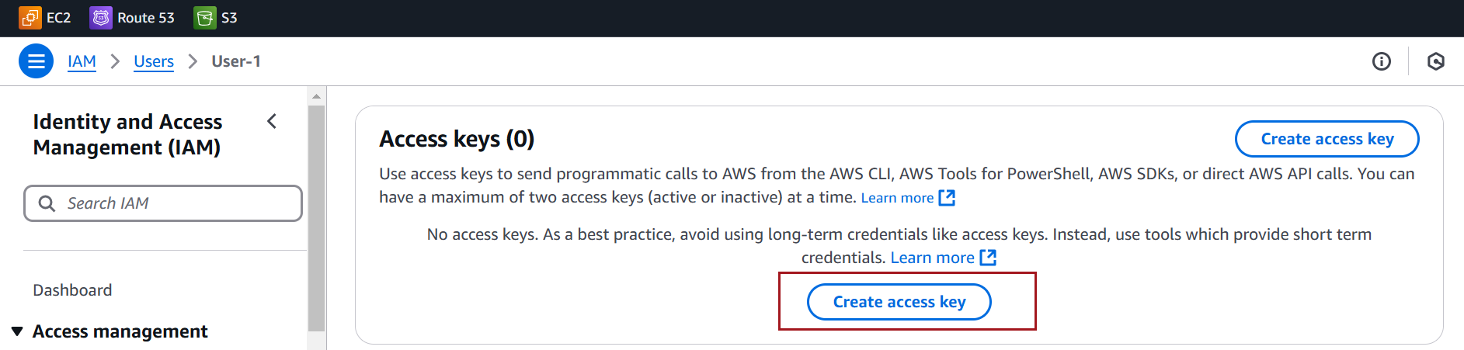

Choose **Command Line Interface (CLI)** under Use case

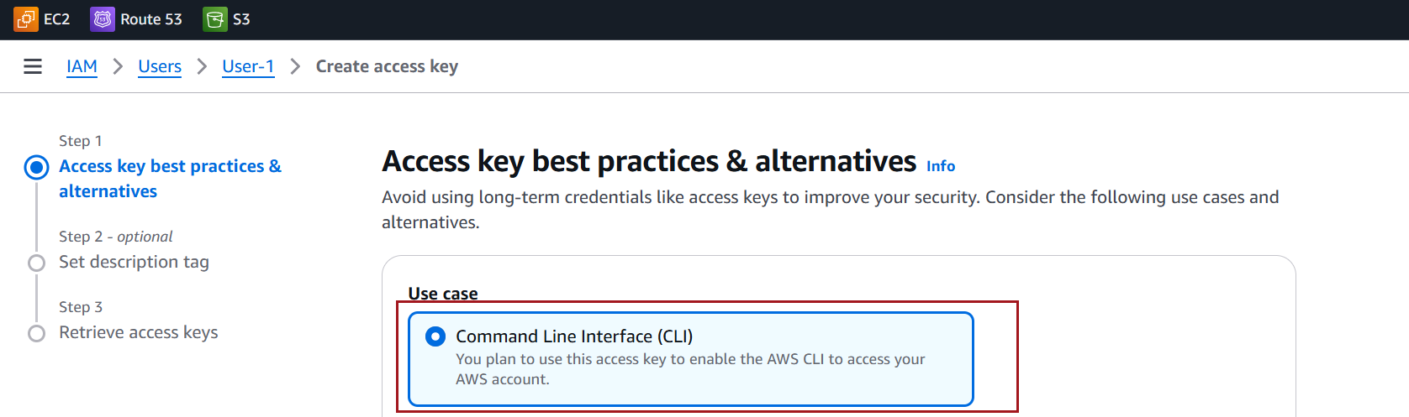

Click **Next**

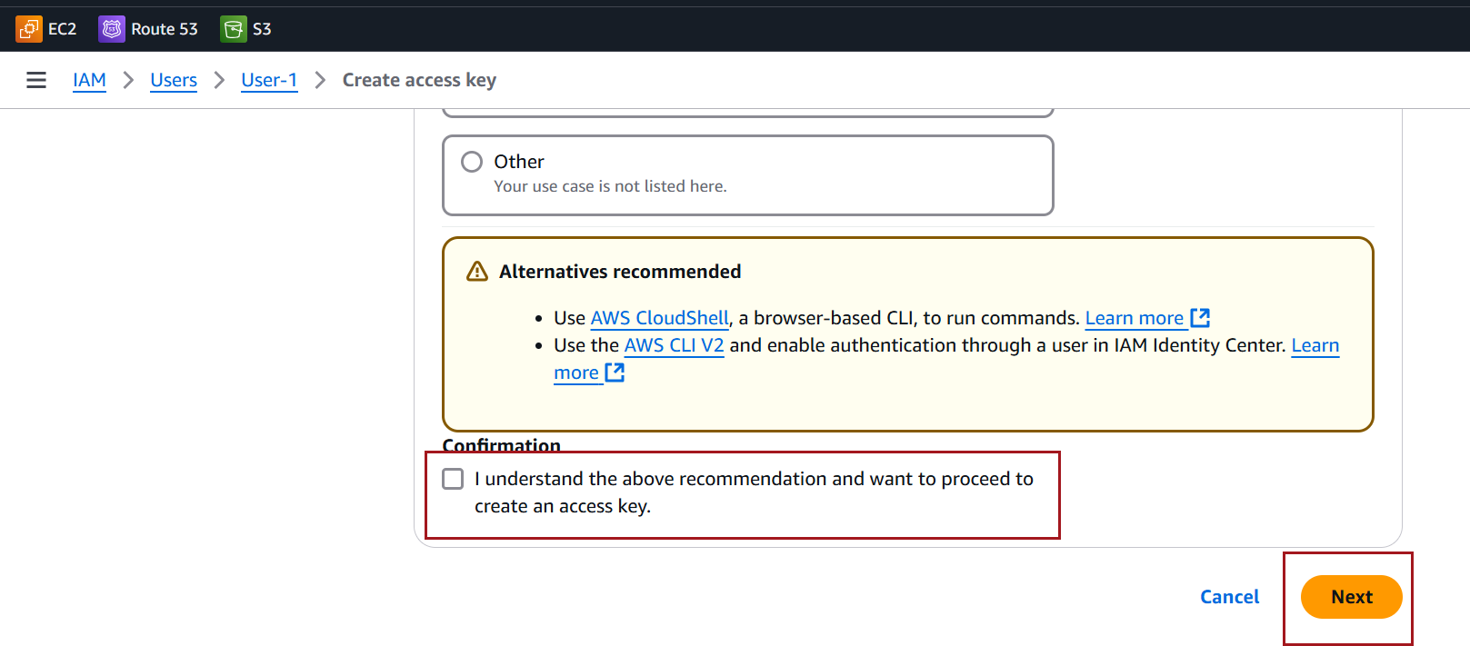

Click **Create access key**

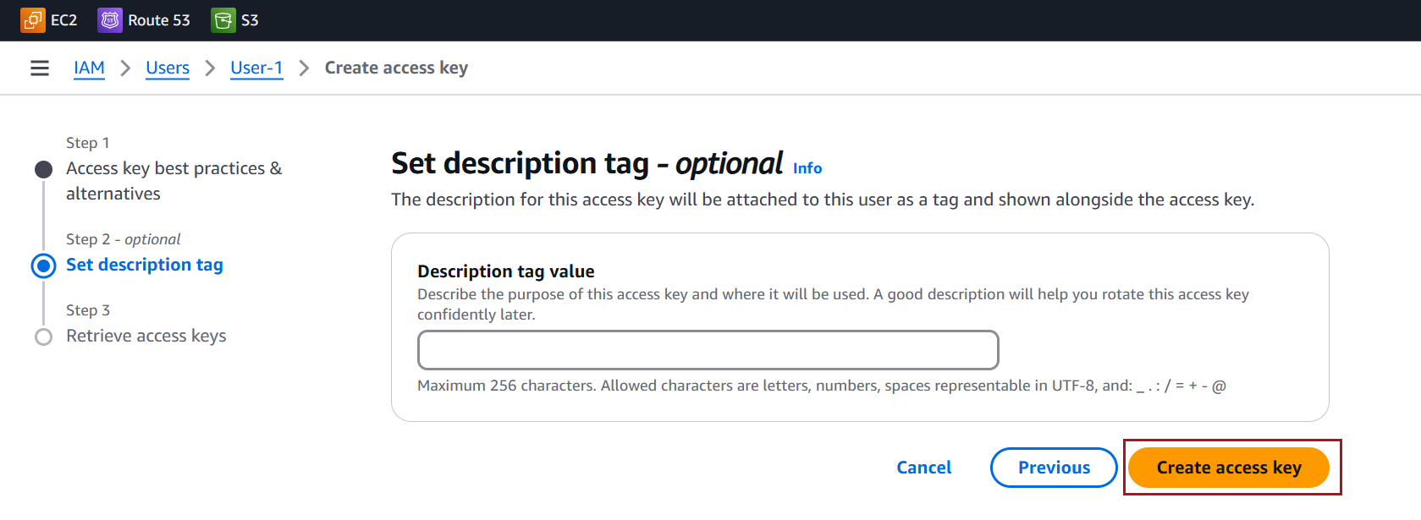

Copy or download the **Access Key ID** and **Secret Access Key** securely

Click Done

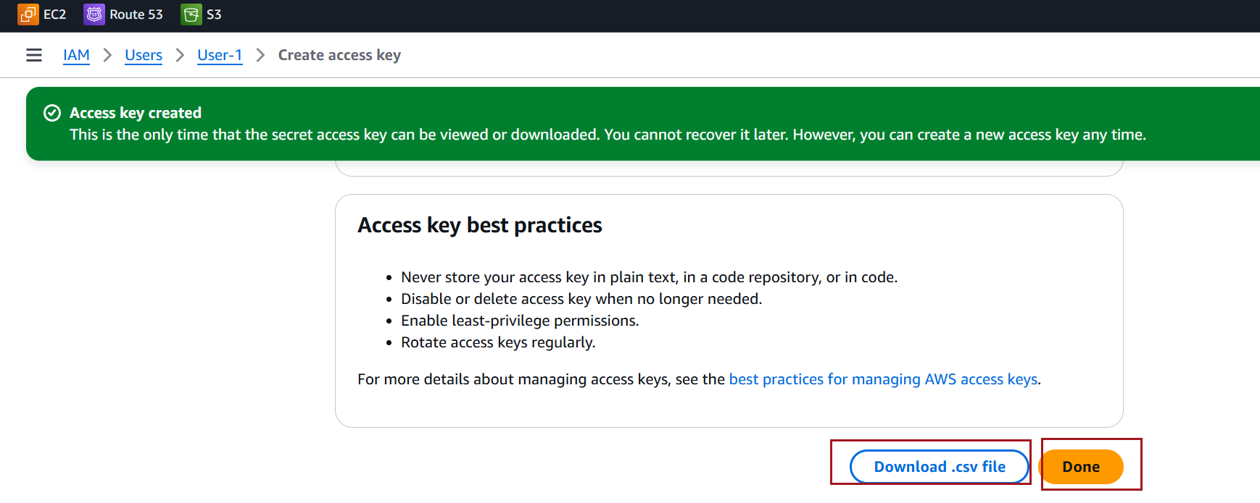

Test IAM user's access

Open a terminal or command prompt

Use the aws configure –profile

When prompted, enter the IAM user's **Access Key ID**, **Secret Access Key**, **default region name**, and **default output format**:

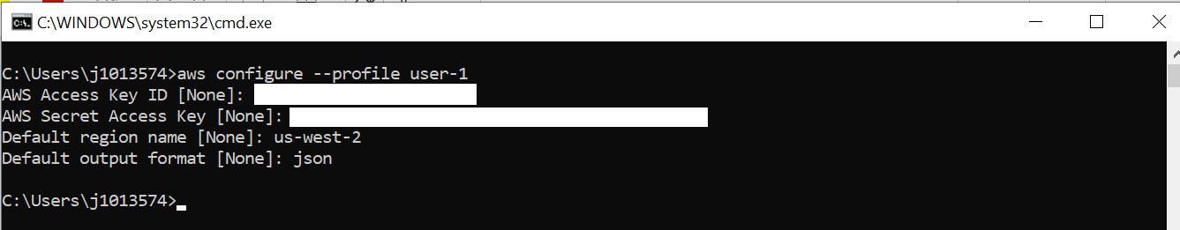

--profile option with AWS CLI commands to test the permission

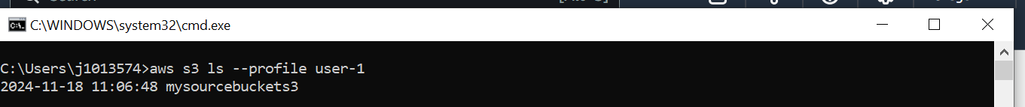

### **Screenshots for** **creating a user group and assign policies in AWS**

Creating groups in AWS is beneficial when you need to manage access permissions for multiple users more efficiently. Assigning permissions to individual users can be tedious. Groups allow you to apply policies to multiple users at once.

Go to **User groups** in the navigation pane, Click on **Create group**.

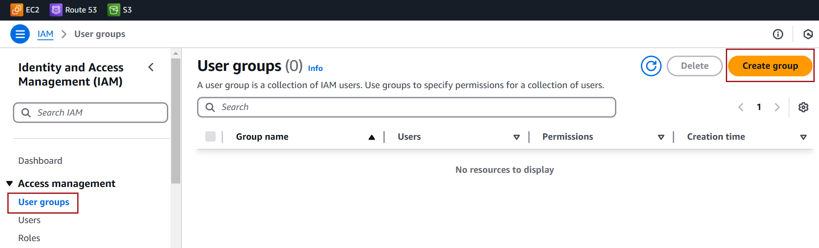

Enter a **Group name**

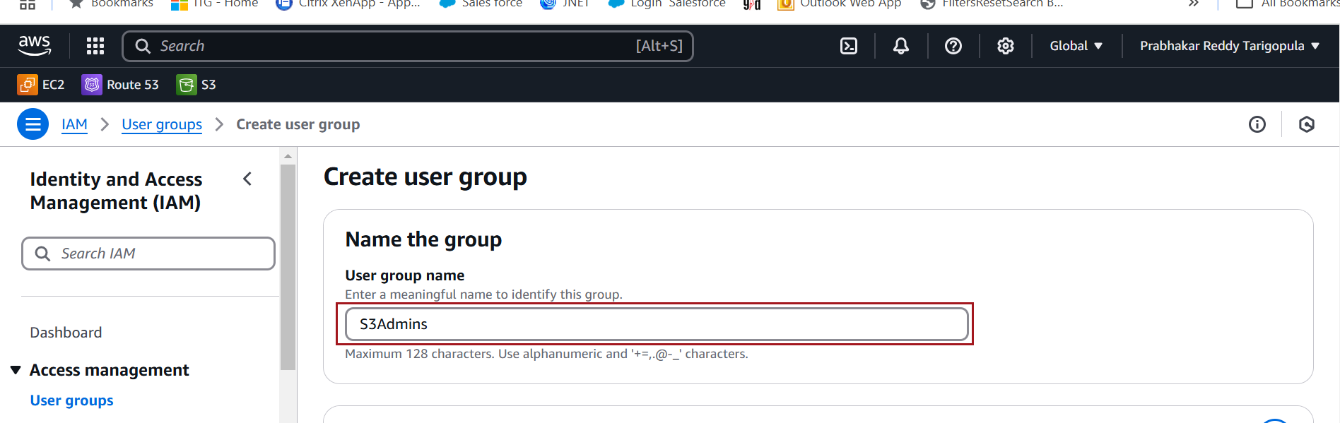

Optionally, assign users to this group during creation by selecting users from the list.

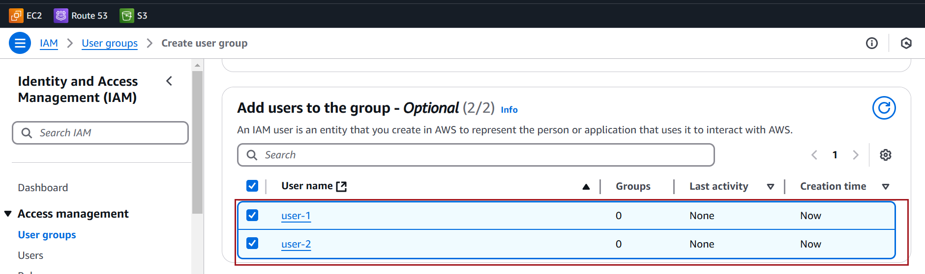

Select the desired policies from the list. You can search by policy name, service, or policy type.

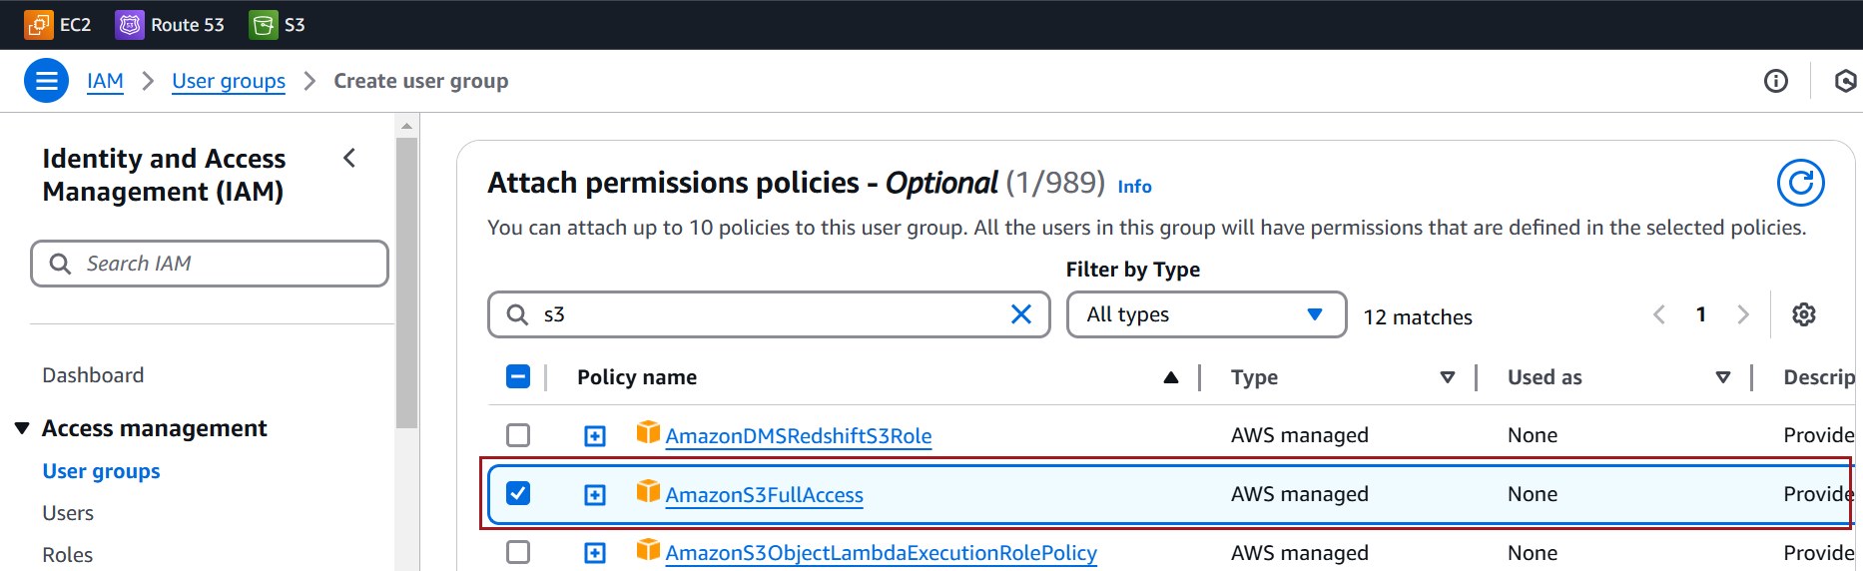

Click **Create group**.

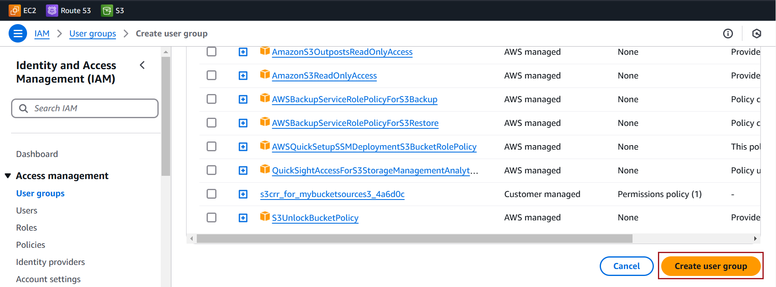

### **Difference between default, customs and inline policies**

In AWS Identity and Access Management (IAM), policies are used to define permissions for users, groups, and roles. The **default**, **custom**, and **inline** policies differ in their use cases, management, and scope

|  |  |  |  |
| --- | --- | --- | --- |
| **Feature** | **Default** | **Customs** | **Inline** |
| **Creation** | Created by AWS | Created by users | Embedded in an entity |
| **Reusability** | Reusable | Reusable | Not reusable |
| **Modifiability** | Not modifiable | Fully customizable | Fully customizable |
| **Scope** | Broad, general use cases | Specific, tailored needs (group or individual) | Entry-specific |
| **Management** | Managed by AWS | Managed by user | Managed by user |

### **Screenshots for** **creating a custom polices**

On the left-hand navigation pane, click **Policies, then** Select the **Create Policy button.**

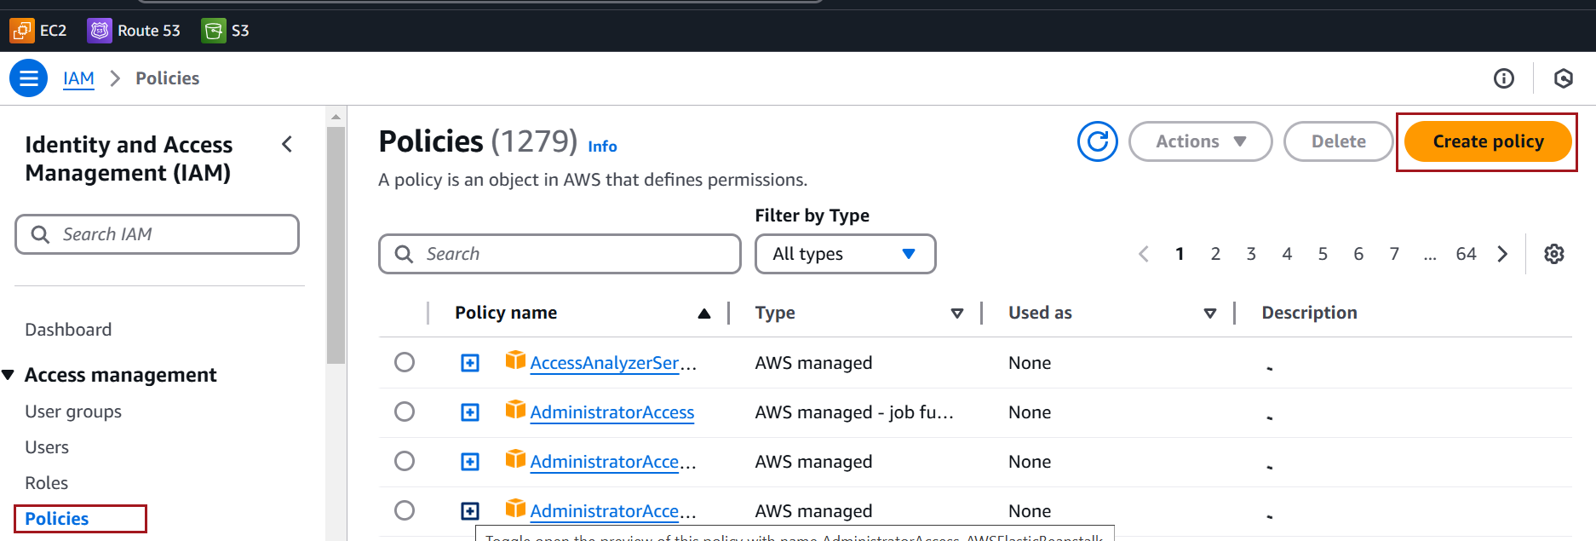

**Choose the Policy Creation Method either by visual editor or JSON**

Under the **Visual Editor** , click **Choose a service**. 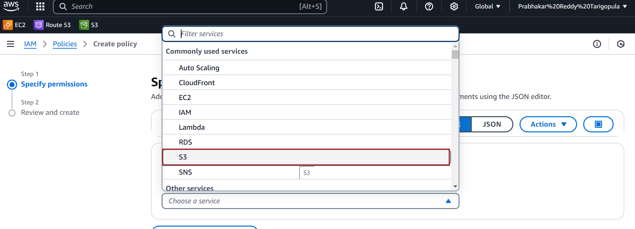

In the **Actions** section, choose the permissions you want

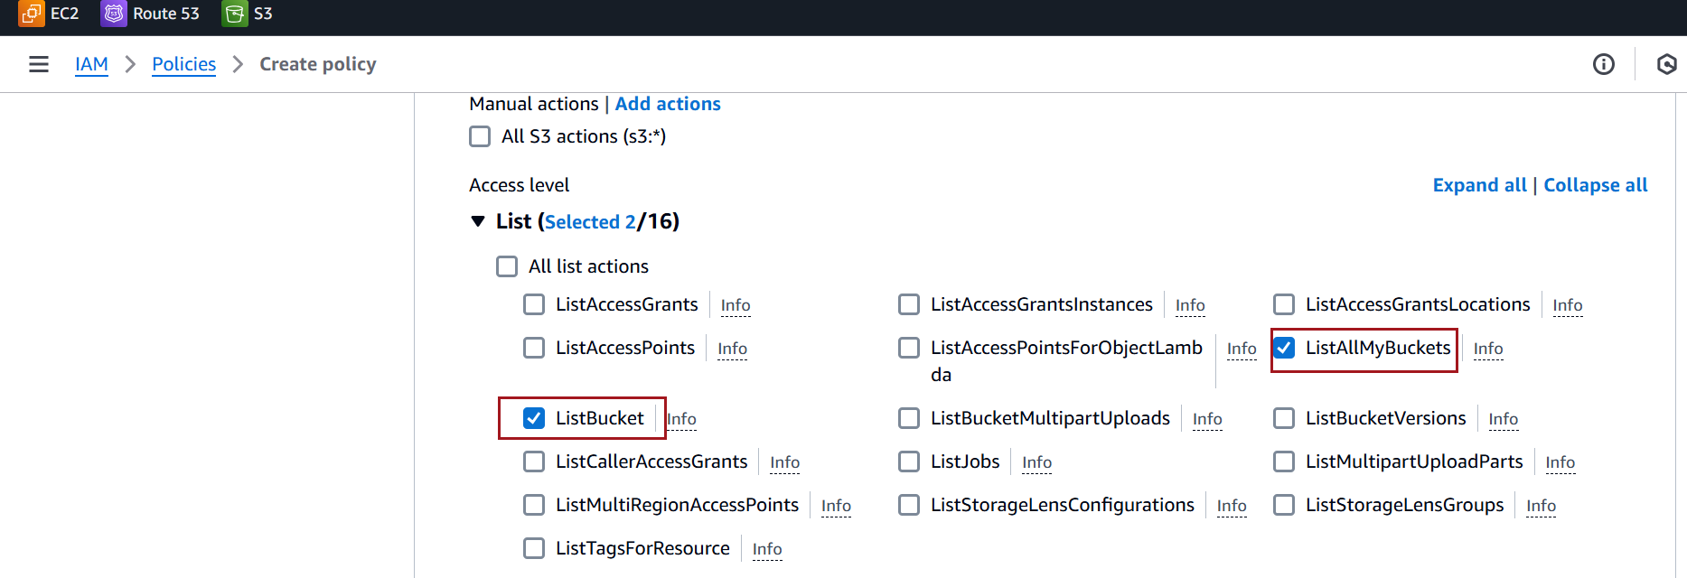

In the **Resources** section, Choose **Specific**

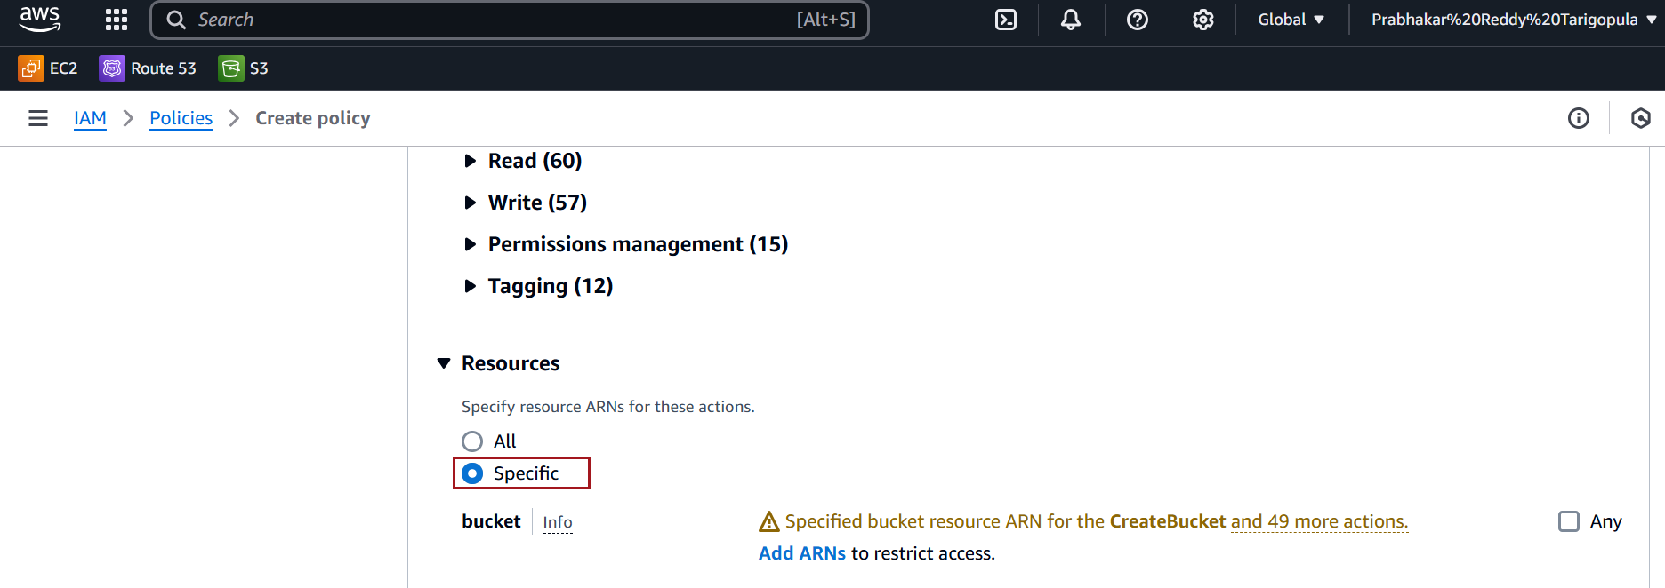

In the **Resources** section, select **Add ARN**

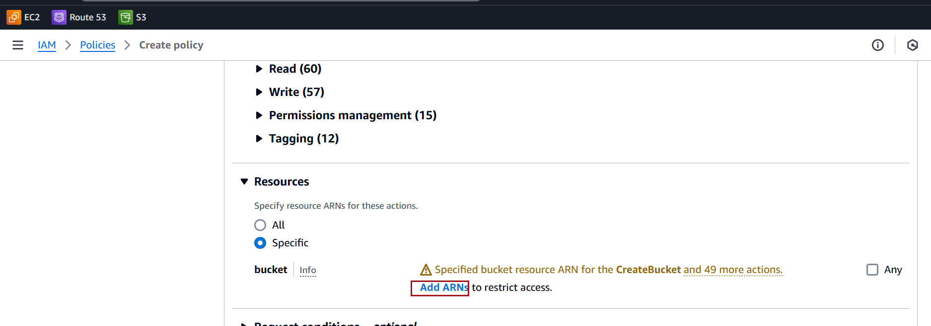

Specify your bucket name **,** click **Add ARNs**

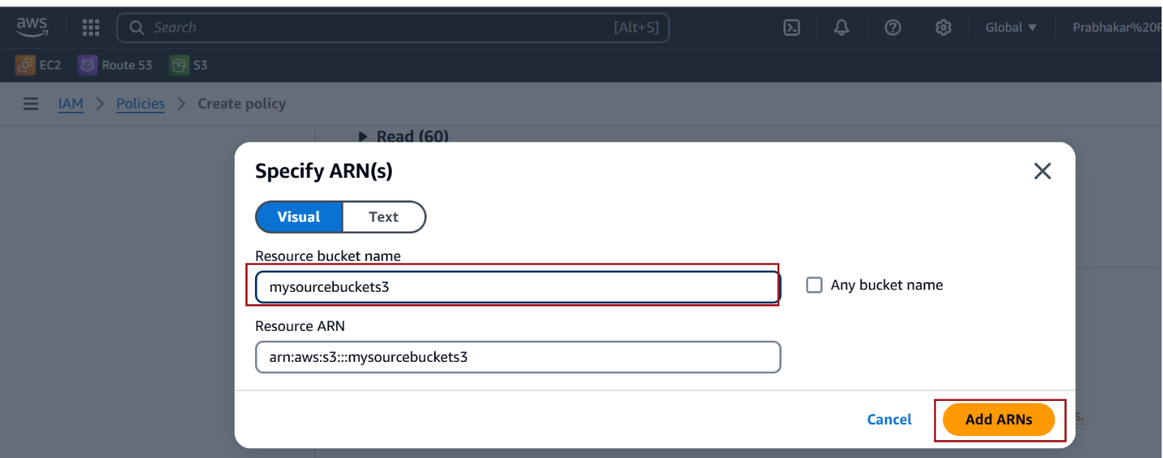

Click on **Next**

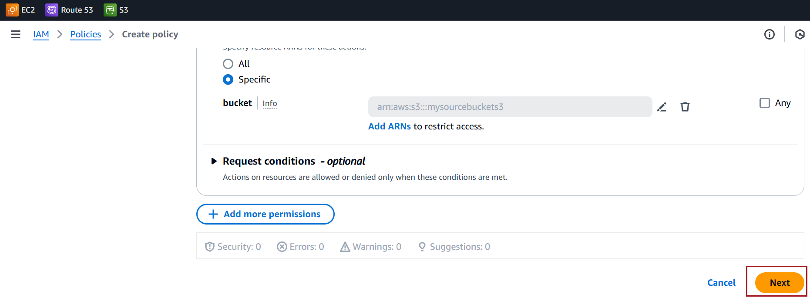

Enter **Policy Name**

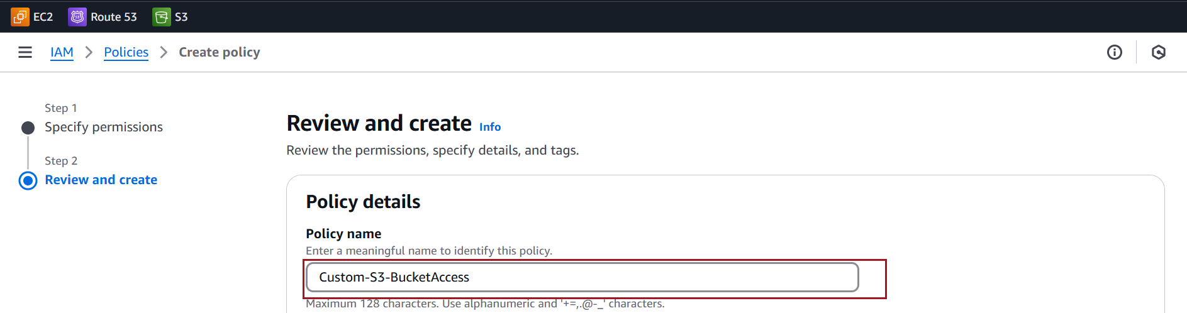

Click **Create Policy**

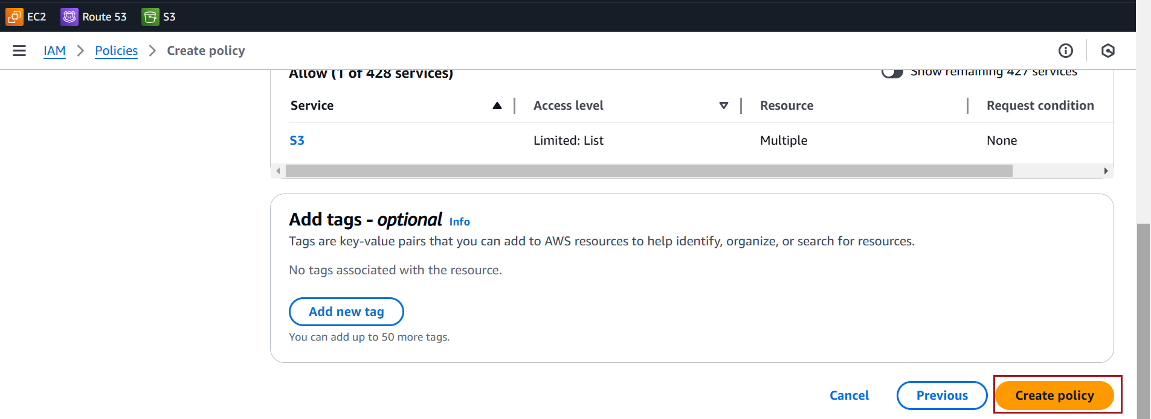

**Assign a Custom Policy to a User**

On the left-hand menu, click **Users**

Choose the user you want to assign the custom policy to from the list

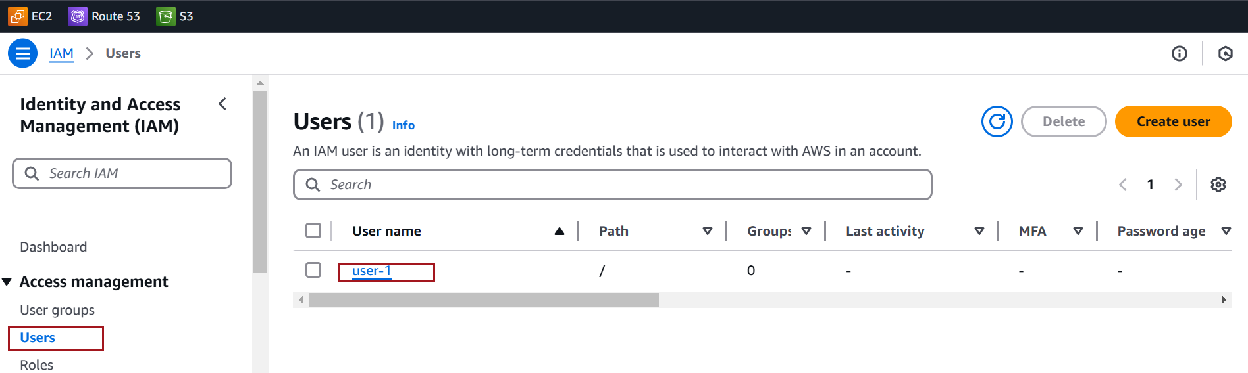

Go to the **Permissions tab** of the user's details, Click **Add Permissions**

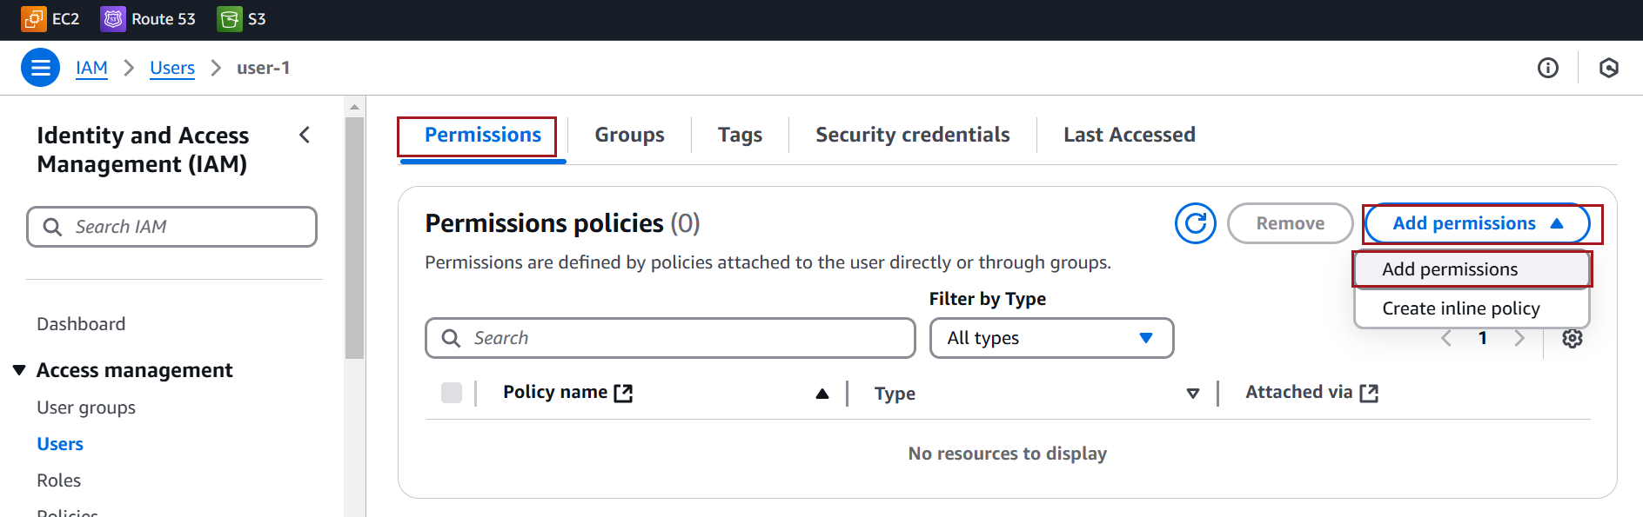

Choose **Attach Policies Directly**

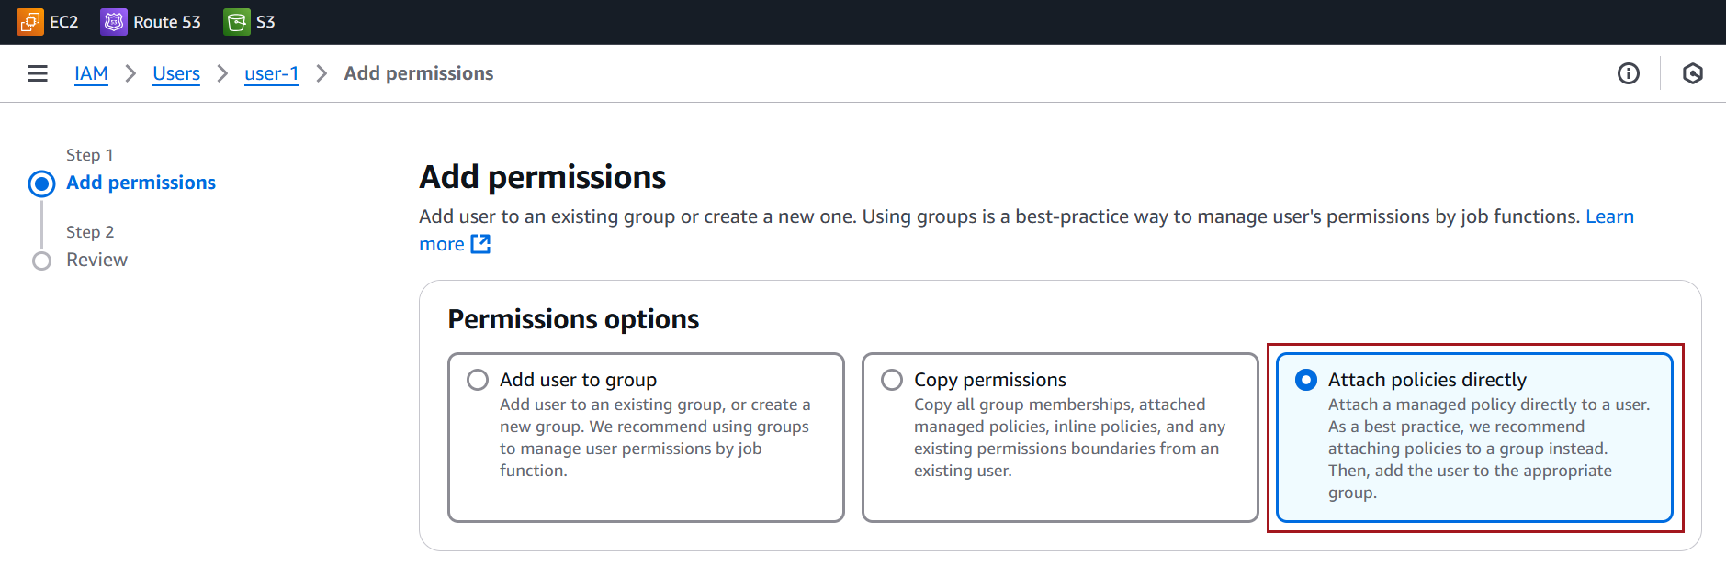

Search for the policy name **Custom-S3-BucketAccess** in the list of available policies

Select the checkbox next to the policy, Click **Next**

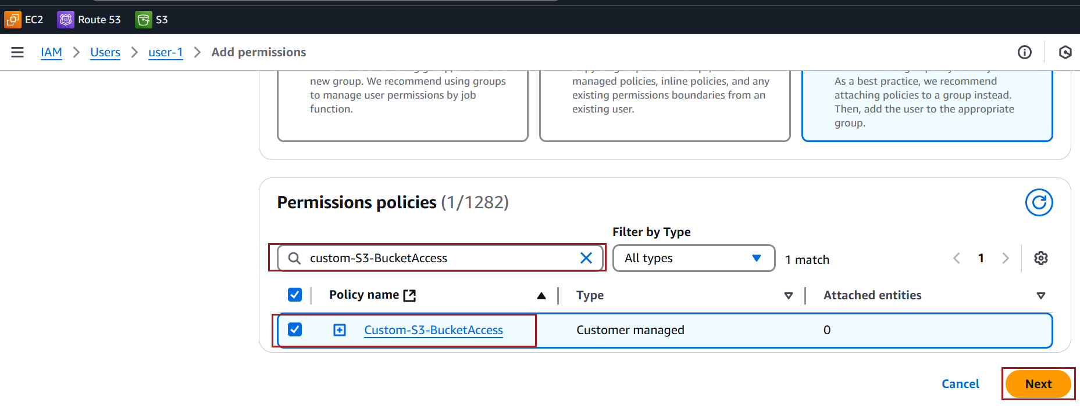

Click **Add Permissions** to attach the policy to the user

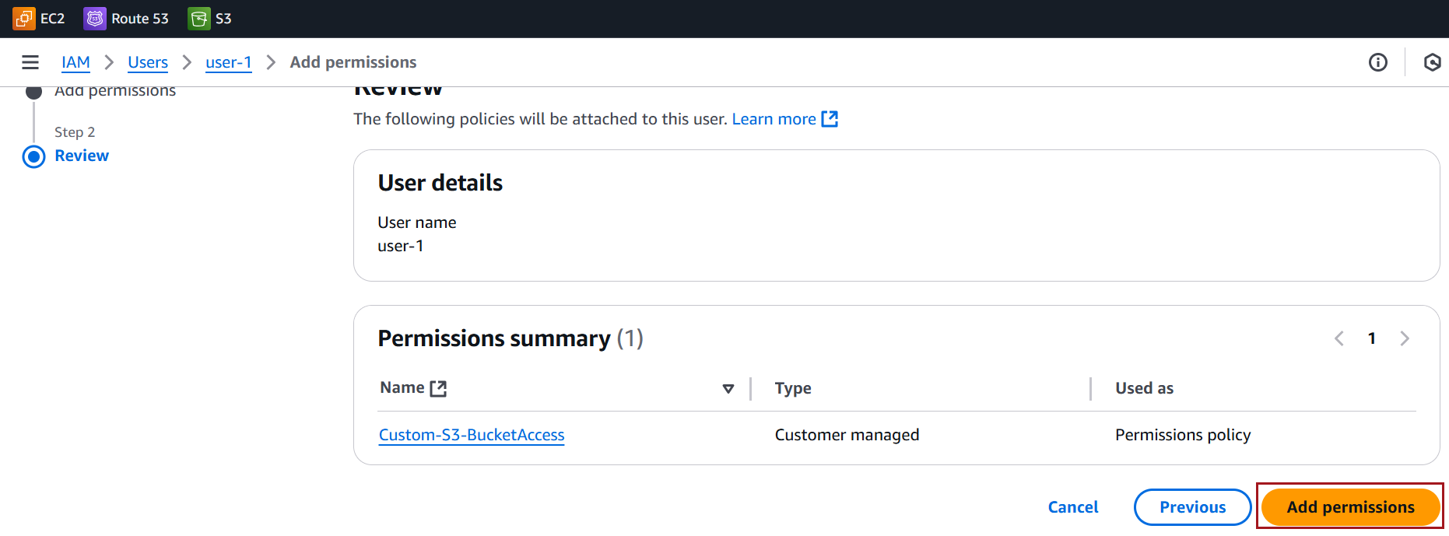

**Testing the Policy**

Log in as the user or assume the user’s credentials.

Copy the **Console sign-in URL**

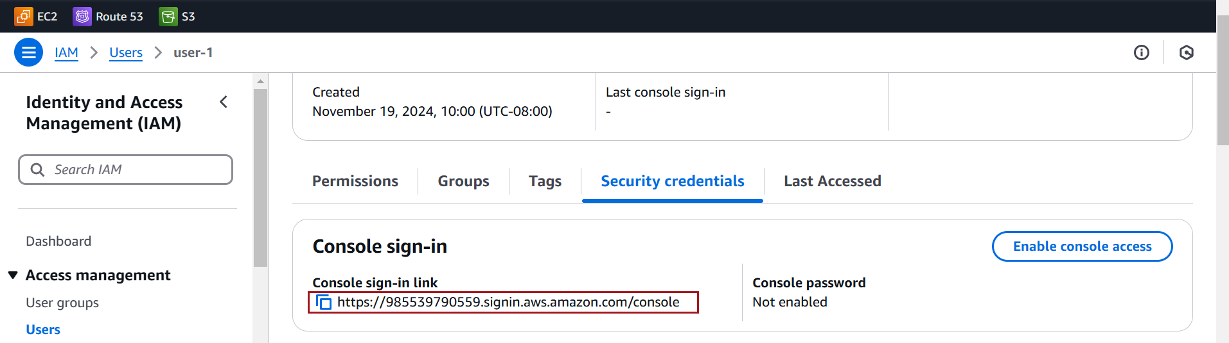

Observe that user is able perform task based on the assigned policies.

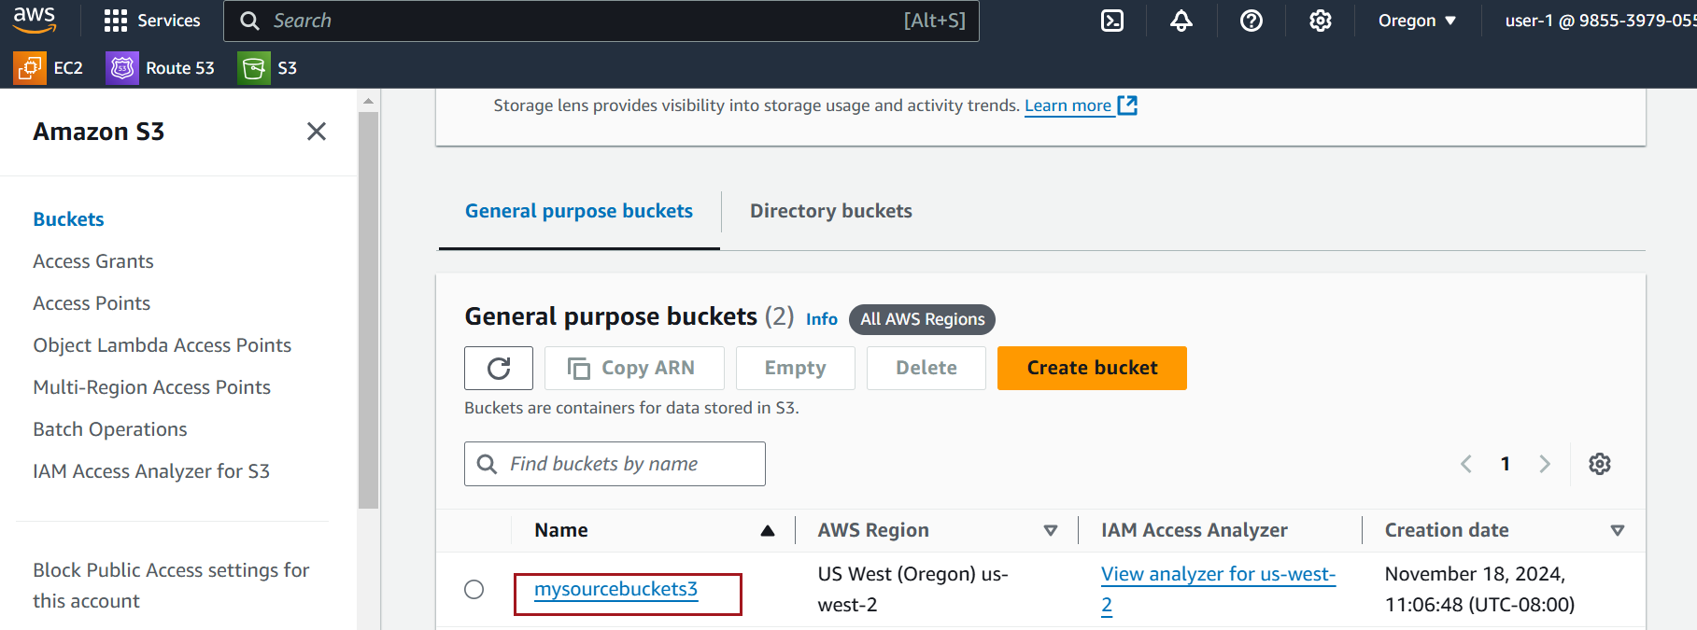

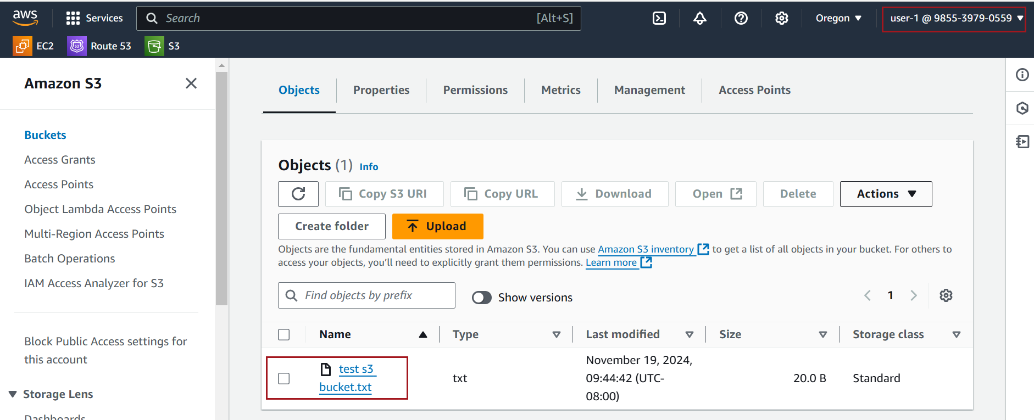

### **Screenshots for** **creating a inline polices**

Select the **User** you want to create the inline policy for

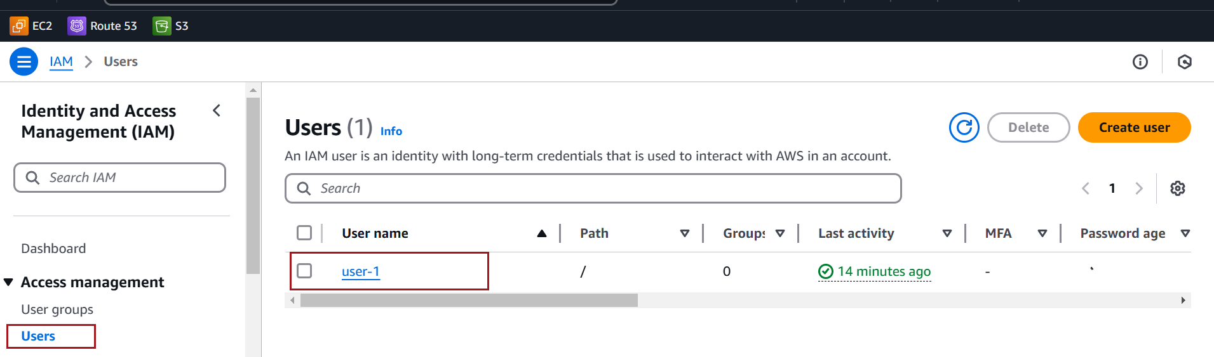

On the **Permissions** tab, Click Add permissions, then Click Create inline policy

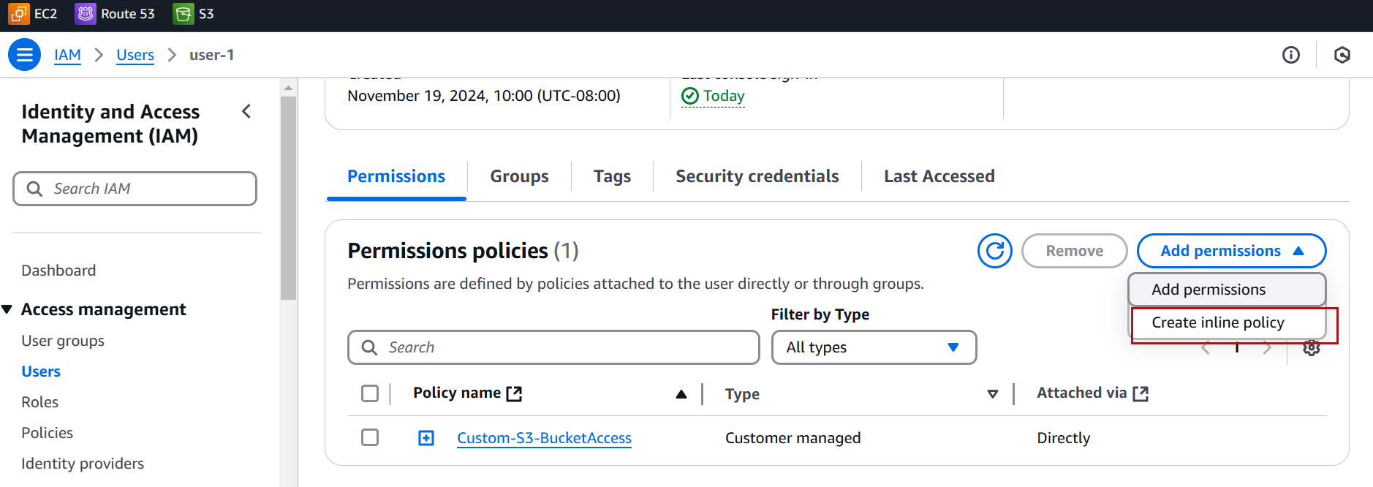

Select the service (e.g., **S3** for S3 bucket access)

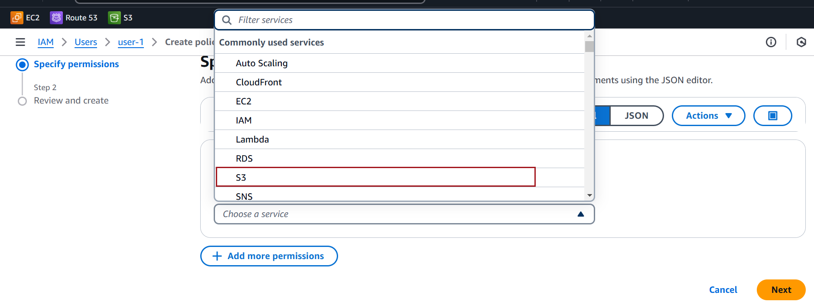

In the **Actions** section, choose the permissions you want



In the **Resources** section, Choose **Specific**



In the **Resources** section, select **Add ARN**



Specify your bucket name **,** click **Add ARNs**



Click **Create Policy**



Enter **Policy Name**

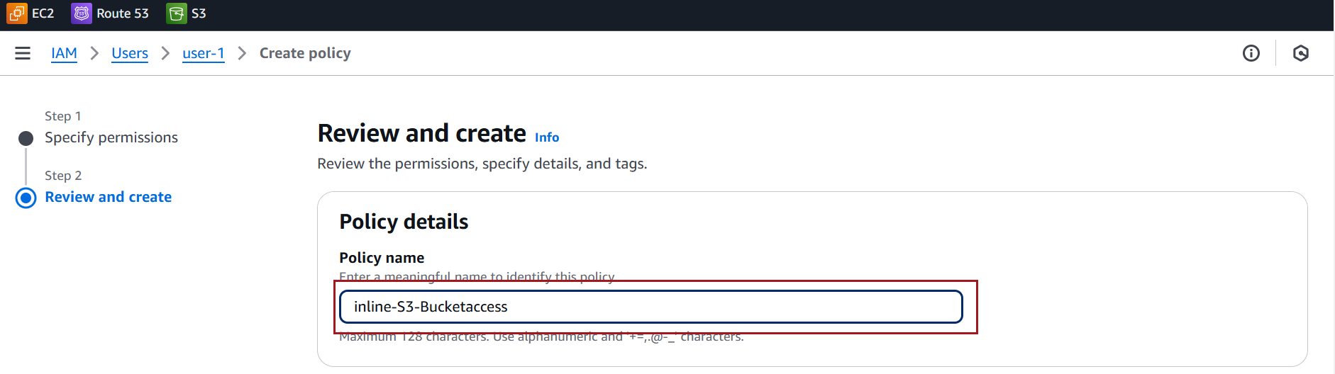

Click **Create Policy**



**Testing the Policy**

Log in as the user or assume the user’s credentials.

Copy the **Console sign-in URL**



Observe that user is able perform task based on the assigned policies.





### **Screenshots for** **creating a IAM Role**

Navigate to [IAM Roles](https://console.aws.amazon.com/iam/home#/roles). Click the **Create Role** button

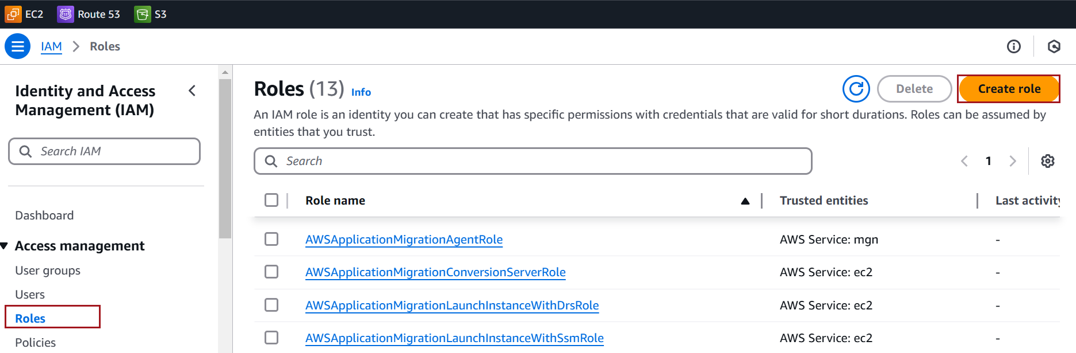

Choose **AWS service**

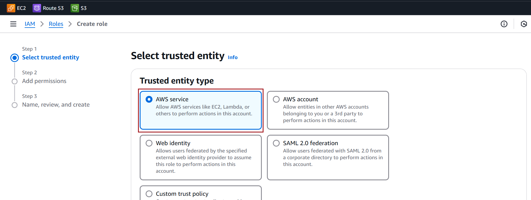

Under **Use case**, select **EC2**

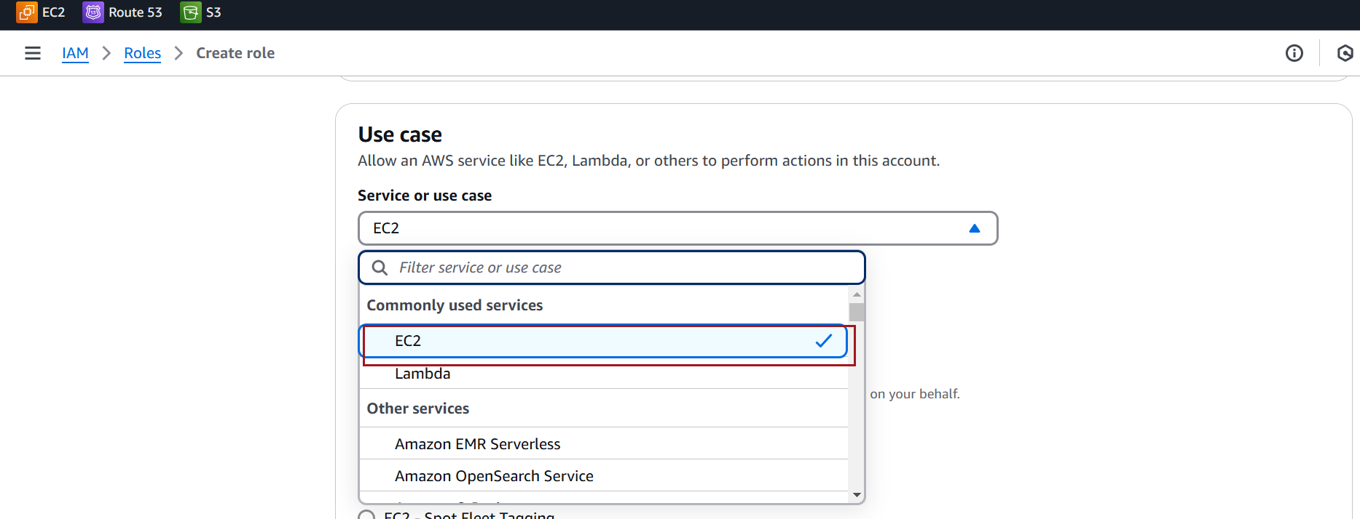

Click **Next**

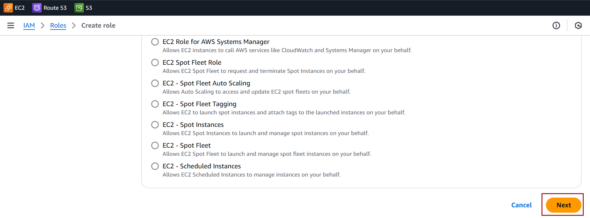

Attach a **AWS Managed Policy**: AmazonS3FullAccess

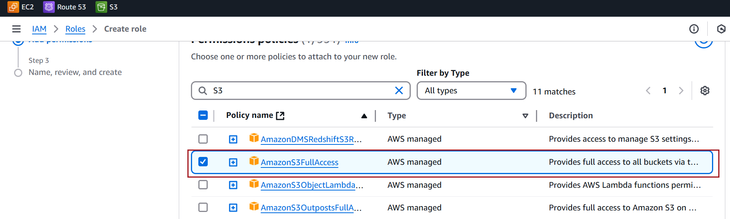

Provide a **name** for the role (e.g., EC2-S3AccessRole).

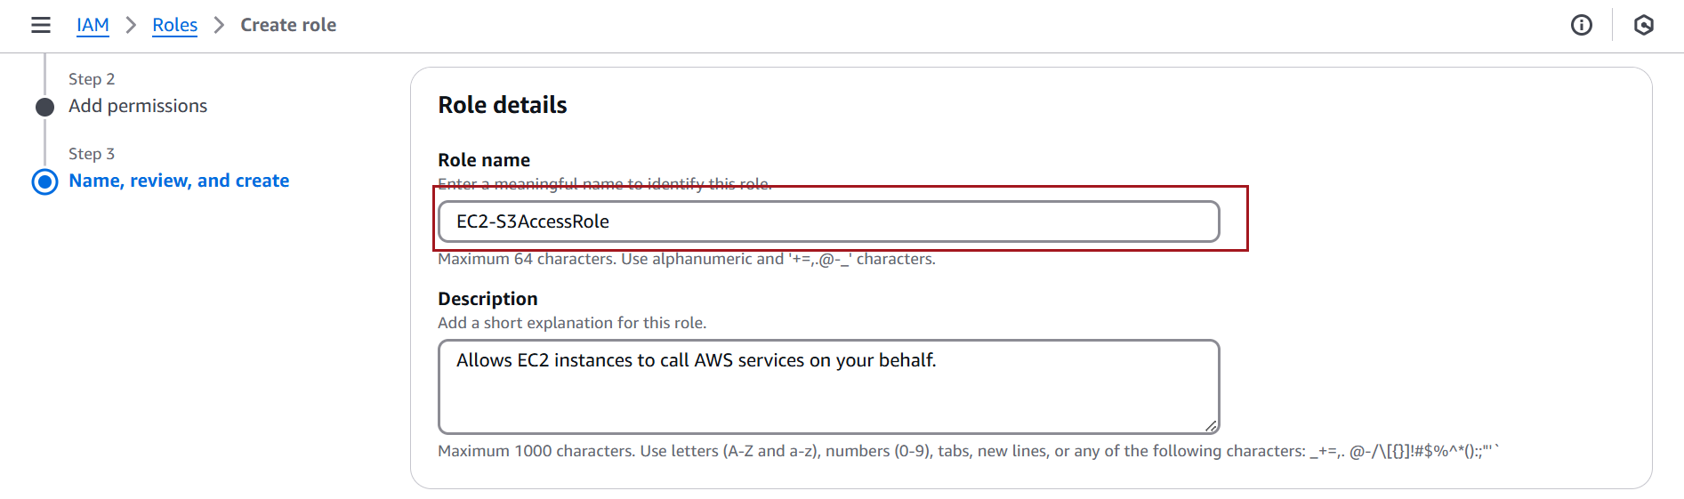

Click **Create Role**

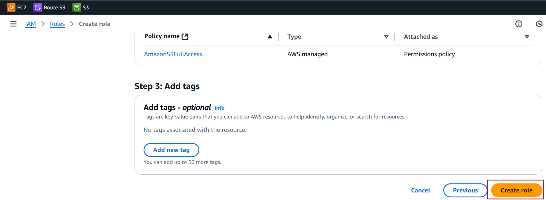

### **Assign and test an IAM role on an Public and private EC2 instance**

#### **Assign and test Role on Public EC2 Instance**

Identify and select the instance you want to attach the role to. Ensure this instance has public access configured (e.g., via **a public IP**)

**Prerequisite -**

The EC2 instance must have an associated security group that allows inbound SSH traffic on port **22**.

Example security group rule:

* Protocol: **TCP**
* Port Range: **22**
* Source: **0.0.0.0/0** (for global access) or specific IP/CIDR range (for restricted access).

With the instance selected, click **Actions** → **Security** → **Modify IAM Role**

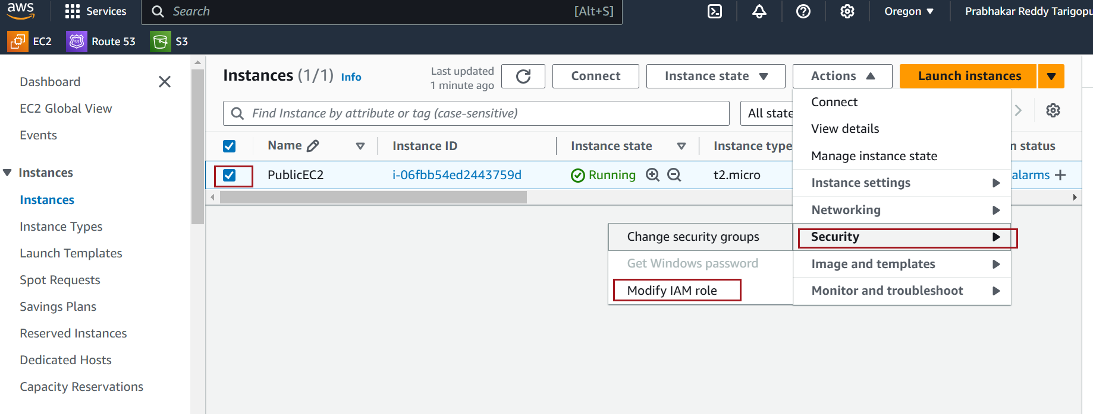

In the **IAM Role** dropdown, select the role you created earlier (e.g., EC2-S3AccessRole).

Click **Update IAM Role**.

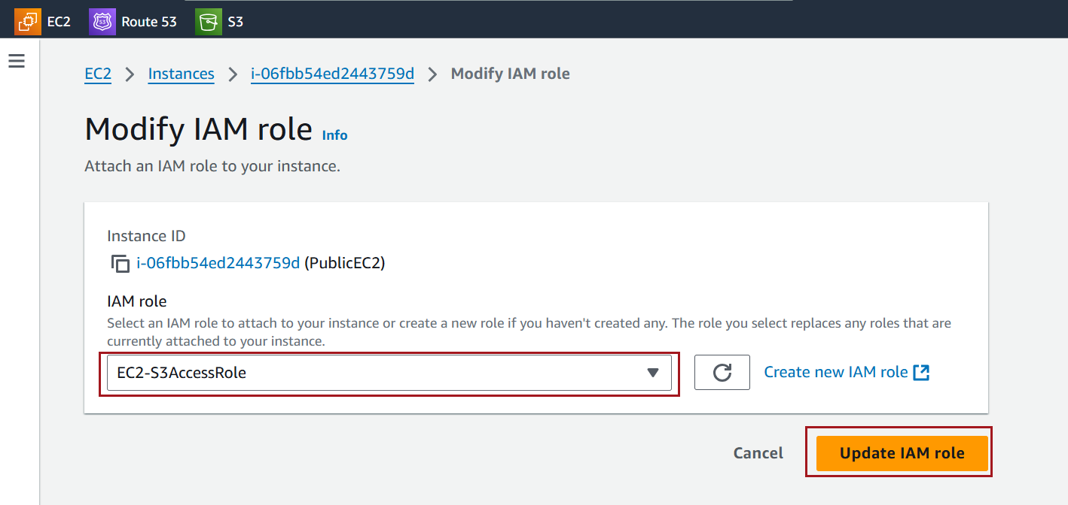

Test Access

Use SSH or Session Manager to connect to the EC2 instance. If it's public, use the public IP

Use the AWS CLI to confirm access to the assigned AWS services. For example, to test S3 access:

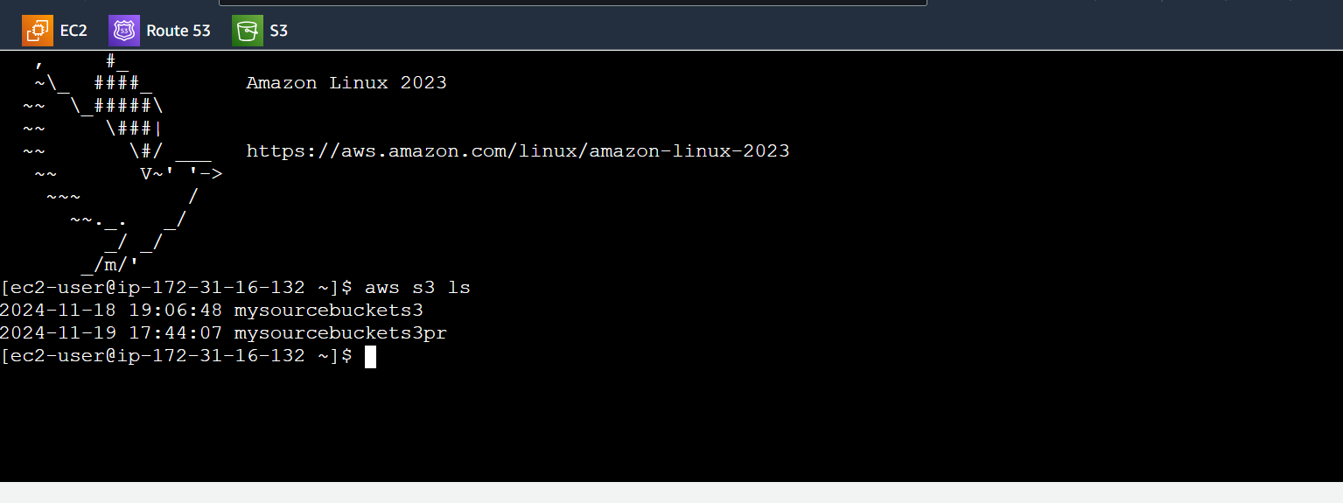

#### **Assign and test Role on Private EC2 Instance**

To access the AWS CLI from a private server (such as an EC2 instance or an on-premises machine without public internet access), specific AWS services like VPC Endpoints or a NAT Gateway are required to enable secure access to the AWS API without direct public internet connectivity.

**Prerequisite -**

The EC2 instance must have an associated security group that allows inbound SSH traffic on port **22**.

Example security group rule:

* Protocol: **TCP**
* Port Range: **22**
* Source: **0.0.0.0/0** (for global access) or specific IP/CIDR range (for restricted access).

Use a VPC Endpoint (Recommended for Private Subnets)

**Create a VPC Endpoint**:

Go to the [VPC Console](https://console.aws.amazon.com/vpc/), Choose **Endpoints** → **Create Endpoint**

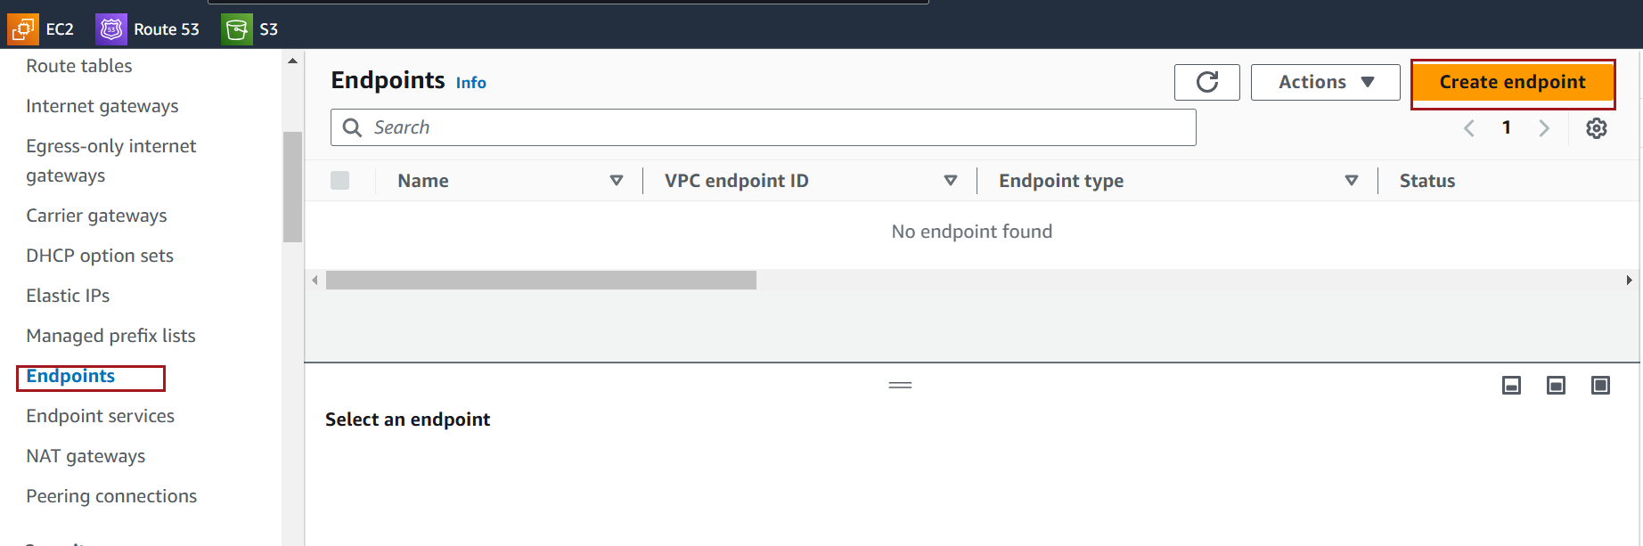

Choose AWS services **Endpoint type**

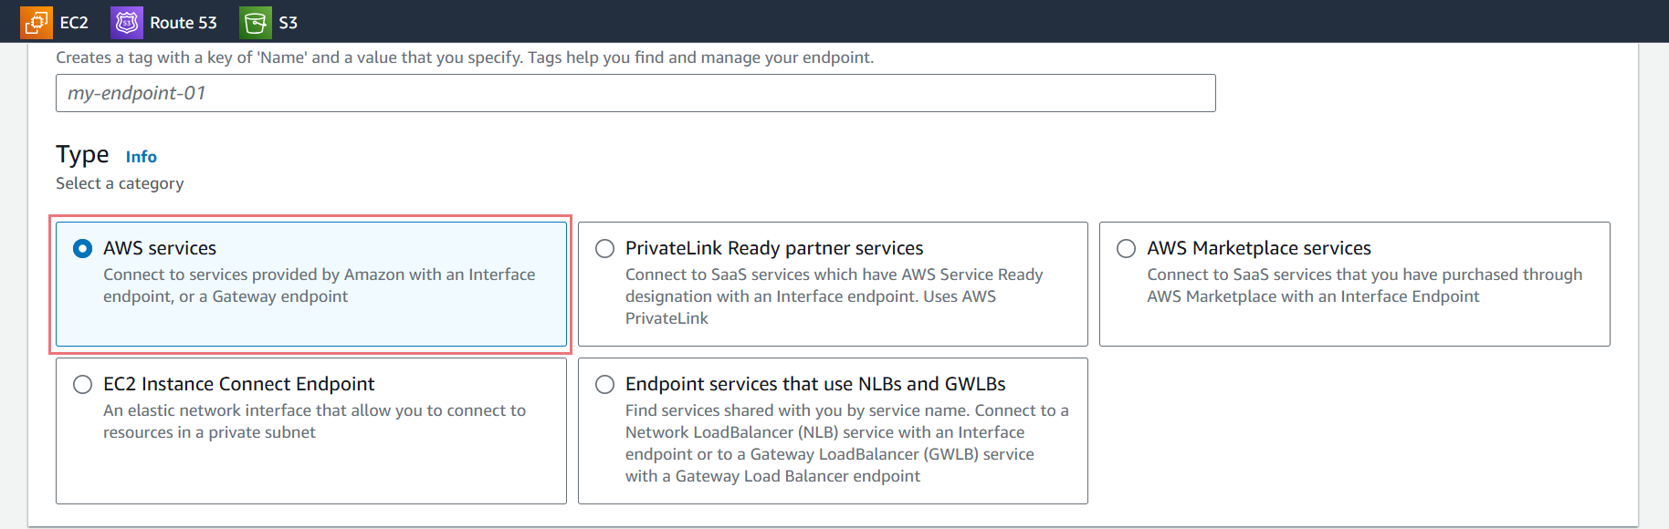

In the **Service Name** search box, select the below service. For example com.amazonaws.us-west-2.s3

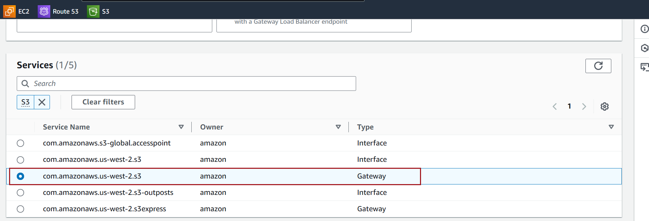

Choose the **VPC** in which you want to create the endpoint. This is typically the VPC where your EC2 instances or other resources reside.

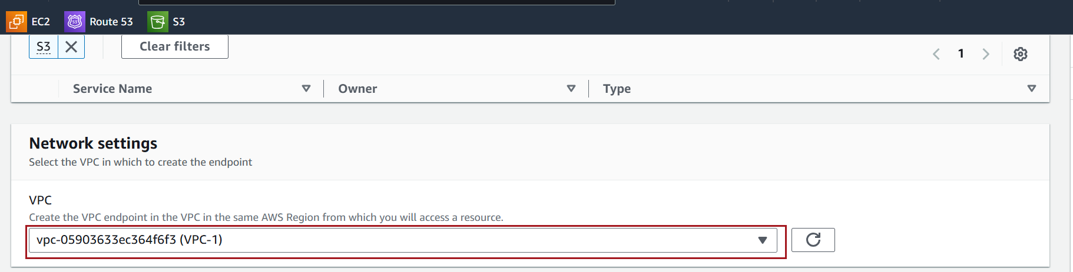

Select the **Route Table(s)** in the VPC that need to be updated to route traffic to the S3 endpoint.

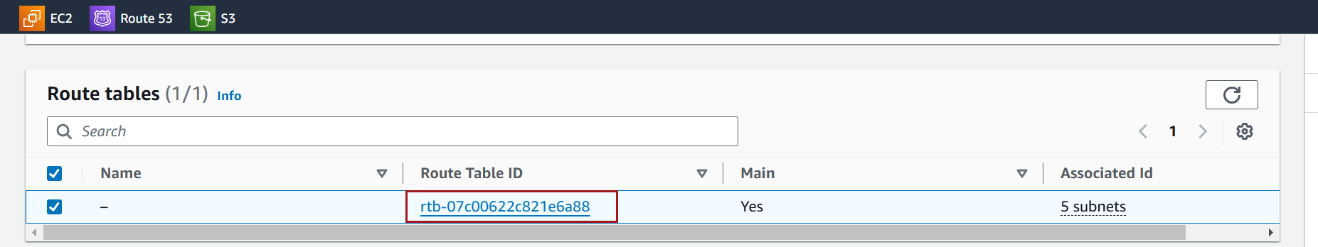

Select Full access **Policy**

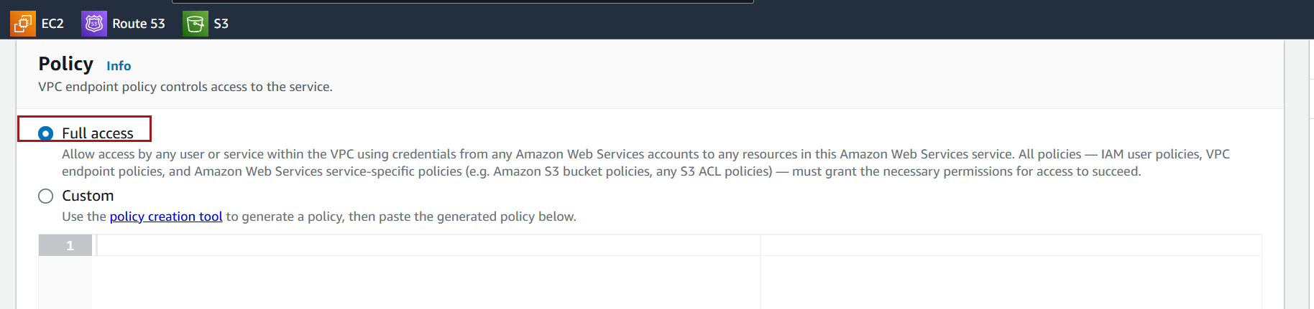

Click **Create Endpoint** to create the S3 Gateway Endpoint

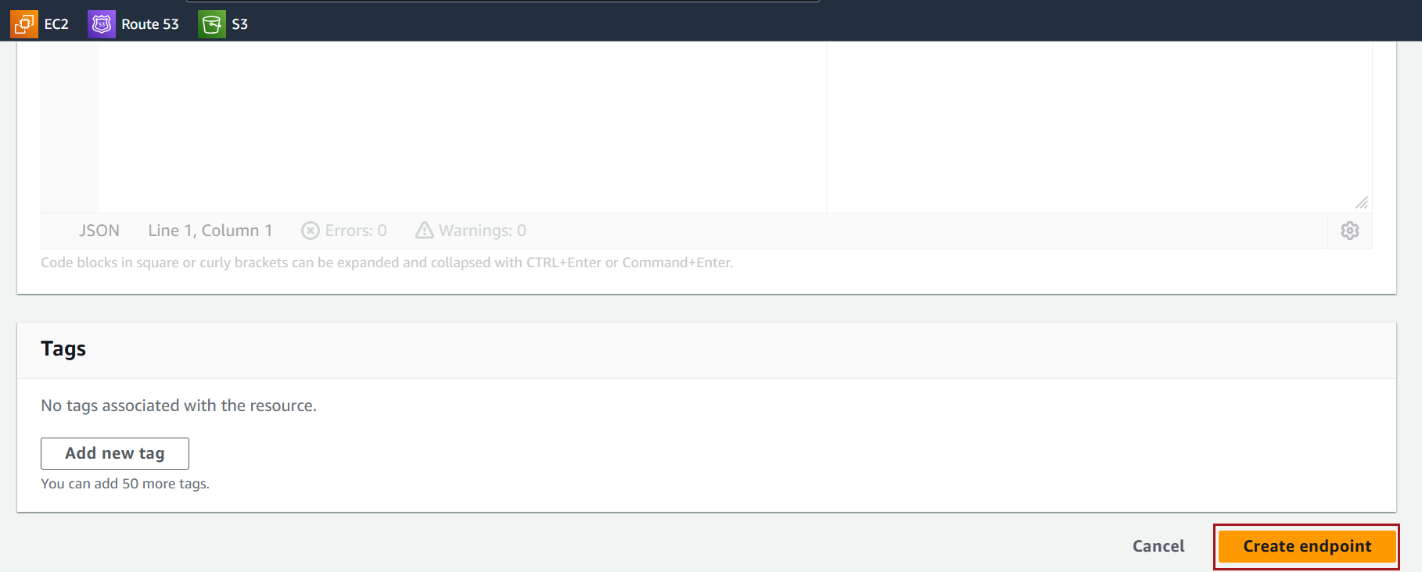

Once the endpoint is created, the route tables will automatically be updated with the appropriate route for accessing S3.

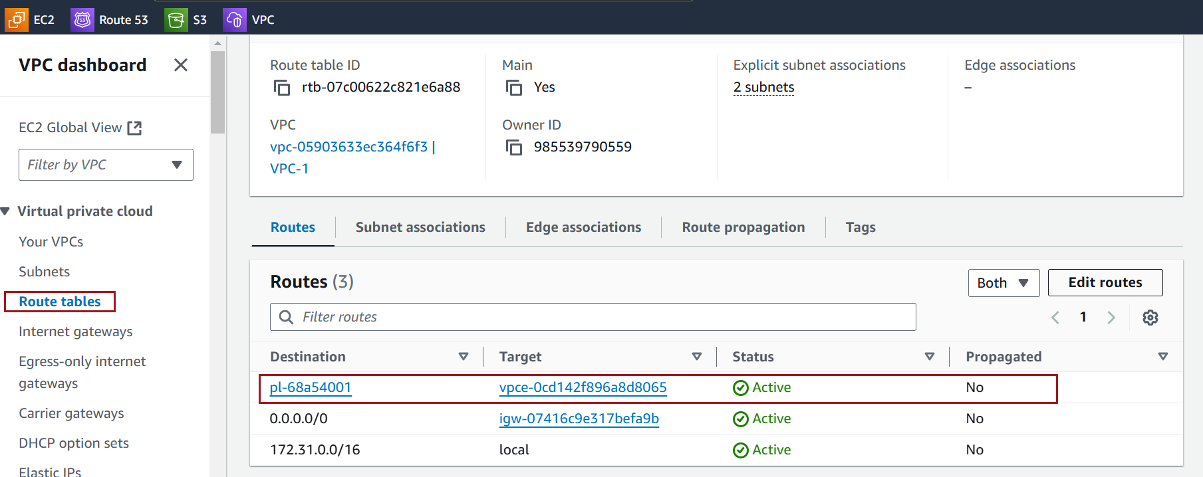

Observe that you're getting the **"Unable to locate credentials"** error because the **IAM role** is not attached to your **EC2 instance**

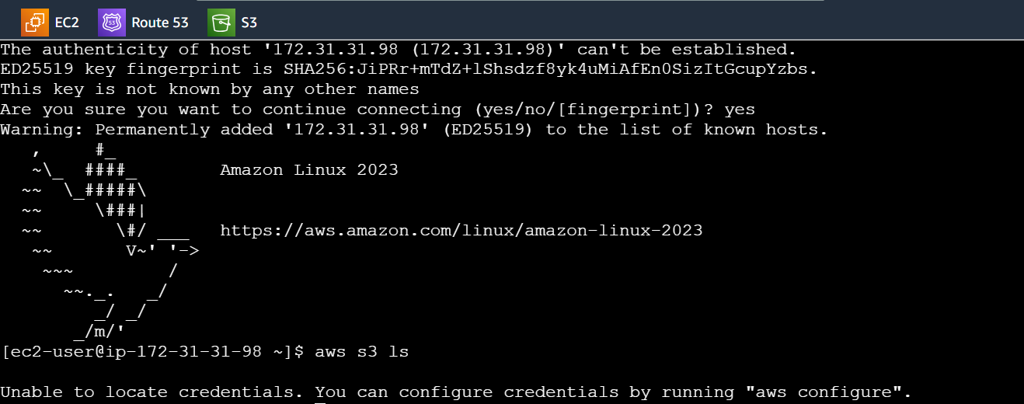

With the instance selected, click **Actions** → **Security** → **Modify IAM Role**

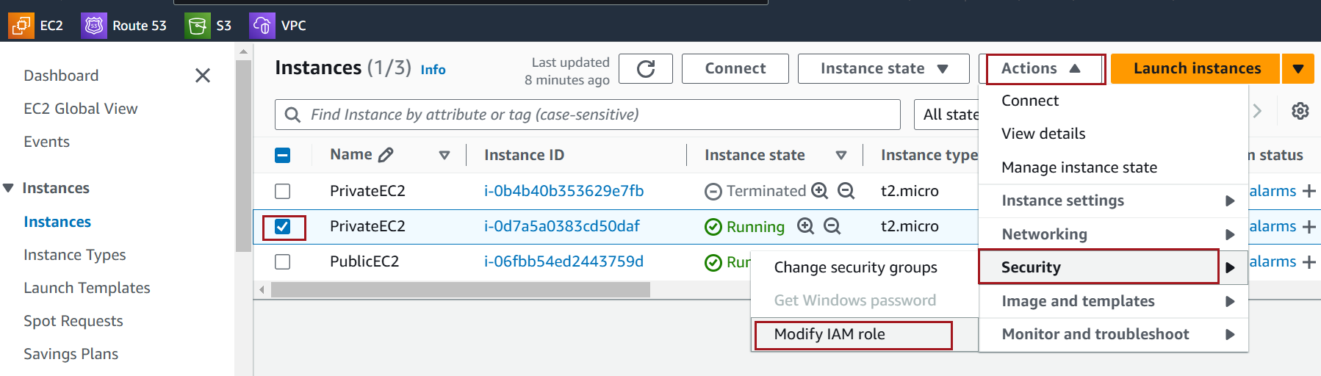

In the **IAM Role** dropdown, select the role you created earlier (e.g., EC2-S3AccessRole).

Click **Update IAM Role**.

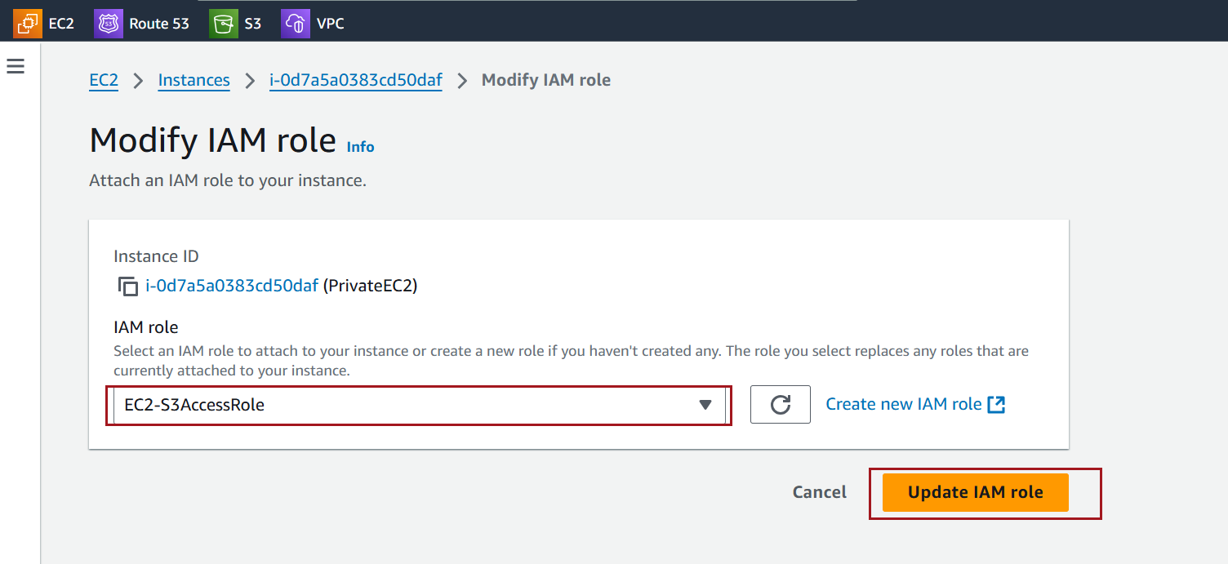

Use the AWS CLI to confirm access to the assigned AWS services. For example, to test S3 access

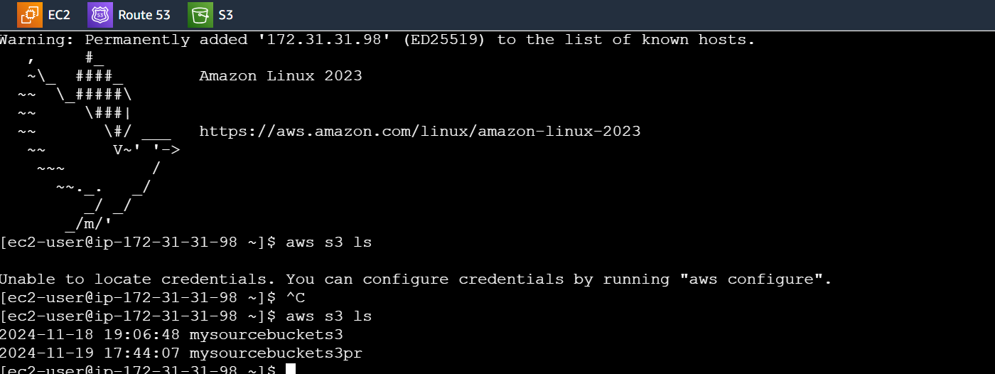

**Use a NAT Gateway or NAT Instance**

After enabling a **NAT Gateway** in your VPC, your private EC2 instances should be able to access the internet and AWS services. Here's how to verify that the **AWS CLI** access works properly from a private EC2 instance

